Beacon Hill Striders (Performance Running)

Training Article: Autumn 2023
Is ‘Lactate Threshold Training’ the key to success?
The most significant middle/long distance athlete in the world in recent years is undoubtedly Norway’s Jakob Ingebrigtsen. … Ever since claiming the European 1500m & 5000m double (as a 17-year-old!) at the 2018 (Berlin) European Athletics Championships Jakob has dominated World middle/long distance running. The only athlete who compares is Kenya’s Faith Kipyegon. But whereas Kipyegon is very much a product of the Kenyan training system, Jakob has pioneered a new kind of training based almost exclusively upon Lactate Threshold Training.
This Article seeks to: Explain the theory and practice of Lactate Threshold Training; Examine the benefits of this method of training; & Offers practical advice and examples on how to implement this in your own training practice.
Lactate Threshold Training: The ‘Theory’
Lactate Threshold Training refers to training at the range of paces between what sports scientists have termed the ‘Aerobic Threshold’ and the ‘Anaerobic/Lactate Threshold.’ … Other terms synonymous with these are: Ventilatory Threshold (for the Aerobic Threshold); and OBLA (Onset of Blood Lactate Accumulation) and MLSS (Maximum Lactate Steady State) (for the Anaerobic/Lactate Threshold). … This can be best represented in a graph of blood lactate concentration in relation to work intensity (running pace) …
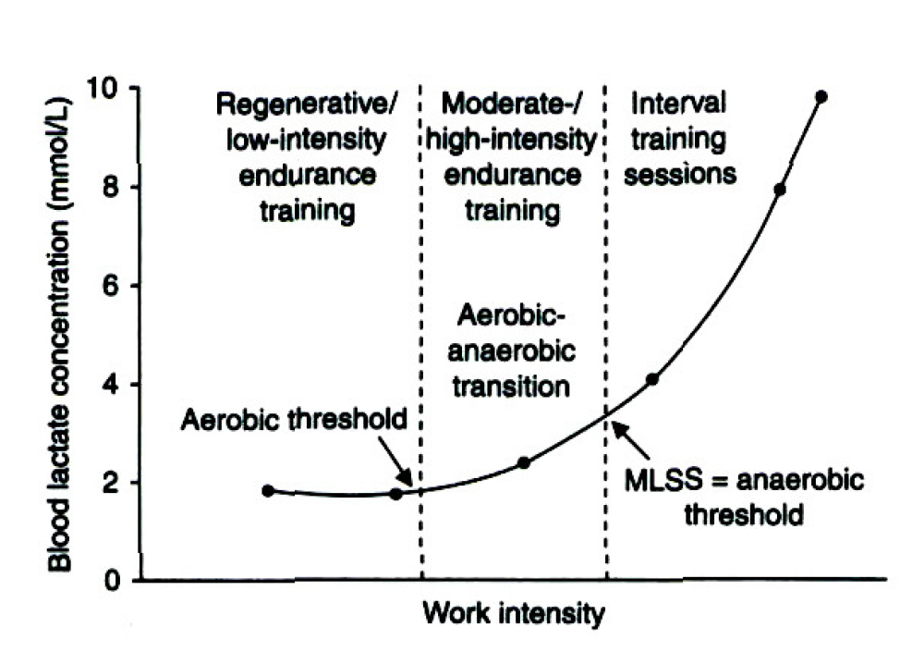
Based on a wealth of data the starting point of this Lactate Threshold zone roughly equates to a runner’s Marathon race pace (MP) (typically 2-3 hours of running) … As MP is considered to be 99% Aerobic, this makes perfect sense. … At running paces slower than MP an individual’s lactate concentration levels remains constant at or below around 1.5 mmol/L. Over and above this pace, lactate begins to accumulate but (initially) at a very steady & sustainable pace. When one nears the end of this zone, typically at Half-Marathon race pace (HMP) or marginally faster, lactate levels are now at or above 3.5 to 4.00 mmol/L. … Running faster than the Lactate/Anaerobic Threshold will see lactate accumulating at a much faster rate and the runner will perceive the effort to maintain this faster pace as decidedly ‘hard’ rather than ‘moderate.’
(Note: Work intensity could of course be defined in terms of ‘% of V02 Max’ or ‘% of Maximum Heart-Rate’ but for the purpose of keeping this relatively simple (and easy to apply!) it is probably best to relate this to specific running paces)
Lactate Threshold Training: Traditional Practice
Lactate Threshold Training (often referred to as Tempo Running) has been a component of most competitive runners’ training programmes for many decades … Ever since the legendary New Zealand coach Arthur Lydiard transformed distance running training practice in the early 1960s, a ‘sustained’ run at a relatively hard intensity has been a key component. Traditionally, this involved sustained running of 20-60 minutes. Lydiard’s athletes (Snell, Halberg, Magee etc) ran a regular (weekly) 10 mile run in 52 to 55 minutes during their ‘Marathon Conditioning’ Base Phase. … In the 1970s and 1980s, ‘fast runs’ of 4-8 miles (20-40 minutes) was a regular feature in the training of UK greats Coe, Ovett, Cram, & Moorcroft. … In the US, Tempo runs of 8-10 miles feature in most of the successful NCAA collegiate programmes of the 1990s and onwards; whilst Kenyan marathon runners (such as Eliud Kipchoge) have regularly run up to 30K at MP or 10-15K at HMP in their race preparations.
Lactate Threshold Training: The Ingebrigtsen Method
The Ingebrigtsen brothers (guided by their coach/father Gjert) have, however, taken this a step further by making Lactate Threshold Training the cornerstone of their training programme, rather than a mere component. … Between 20 & 25% of their training load (which comfortably exceeds 100 miles a week) is run at Lactate Threshold (LT). Additionally, (& this may well be the key factor here) by using the Interval method of doing LT Training (rather than longer sustained runs), they can stay within the Lactate Threshold zone even when running at faster than HMP pace. By inserting short recoveries (30-60 seconds) between efforts they can run at 10K race pace (and even 5K race pace) without moving outside the LT zone. … Needless to say, this is done in a very controlled and professional manner using simple lactate testing kits to regularly monitor lactate levels within each training session. To further re-inforce the effects, specific training days involve ‘double’ sessions run at Lactate Threshold pace. …
A widely published (though unverified) weekly format for Jakob is as follows:
- M: Easy Running (2 x 10Km)
- T: 2 x LT Run Sessions (e.g. 5 x 6 minutes & 10-12 x 1000m)
- W: Easy Running (2 x 10Km)
- TH: 2 x LT Run Sessions (e.g. 6 x 5 minutes & 20 x 400m)
- F: Easy Running (2 x 10Km)
- S: Hill Training (20 x 200m) & LT Run Session (at lower intensity)
- S: Long Run (20Km)
Lactate Threshold Training: ‘Critical Velocity;’ ‘Cruise Intervals;’ and Double Sessions
At this stage it is only fair to point out that the Ingebrigtsen Lactate Threshold Training model (and specifically the use of the Interval format) is not that far removed from earlier systems developed by US running coaches Tom Schwartz and Jack Daniels. … Schwartz coined the term ‘Critical Velocity’ to denote work conducted at around 8-10K race pace, and conducted in Interval fashion. Schwartz has used his training method, typically centred on 800m to 1000m reps (at 8-10K race pace) with short (60-90 seconds) jog recoveries with much success at High School, College, and Elite training levels. … Daniels (famed for his coaching manual, ‘Daniels’ Running Formula’) coined the term ‘Cruise Intervals’ to denote Intervals run at HMP pace. Examples given in his manual include: 5 x 8 minutes; and 8 x 5 minutes (each with 60 seconds recovery). … Perhaps more revolutionary is the notion of doing 2 sessions per day. Even here, however, this echoes the ‘Special Block’ training advocated by famed Italian coach Renato Canova, that sees athletes training at higher intensities twice in one day. … Despite this, the Ingebrigtsen model can be viewed as revolutionary in terms of the systematic implementation of Lactate Threshold Training.
Lactate Threshold Training: The Benefits
Before we move on to look at some practical applications that you could adopt in your own training, it is worth clarifying the benefits that Lactate Threshold Training offers. The key reason to run at or near to the Lactate Threshold running intensity is that it has a positive effect on the lactate curve in our earlier diagram. This is represented as follows:
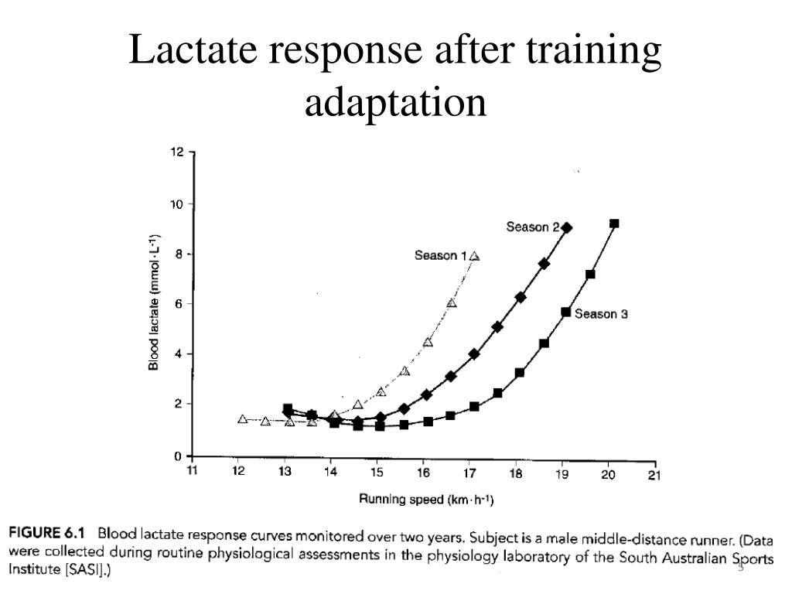
By shifting the lactate curve to the right (through Lactate Threshold Training) the athlete finds that: a) he/she can run the same pace as before but at a lower intensity (i.e. he/she becomes more efficient/economical); & (most significantly) he/she can run quicker at a given training intensity. … In effect, his/her race pace across all distances that rely heavily upon the aerobic system (i.e. 1500m and above) improves. … Additionally, because the intensity is ‘controlled’ the athlete can do more of this kind of training (both in terms of volume and frequency) without incurring the same deep metabolic cost (as running at 5K pace or faster). … The key to the Ingebrigtsen model is that by performing so much of the training load at this Lactate Threshold Training level, the athlete’s lactate curve keeps moving further and further to the right, and he/she becomes faster and faster across all race distances from 1500m upwards.
Lactate Threshold Training: Are the Ingebrigtsens unique?
Before we turn to look at some practical Lactate Threshold Training sessions, we should address the possibility that the success of the Ingebrigtsen brothers (and Jakob in particular) is due to some genetical predisposition … an accident of birth. … If Gjert applied his training methods to other non-family athletes with similar success, then we could safely discount this notion. … Step forward 24-years-old, Narve Gilje Nordås. … In 2023 under the coaching guidance of Gjert Ingebrigtsen, and almost exclusively conducting run sessions at Lactate Threshold intensity, Nordås has gradually improved his 1500m best from 3-36.23 to 3-29.47 (and claimed World Championship 1500m Bronze at Budapest!). … The full story of his meteoric rise can be found here: https://citiusmag.com/articles/gjert-ingebrigtsen-interview-norwegian-training-formula

Furthermore, other middle/long distance runners and run coaches are beginning to adopt and adapt the system, looking to enhance the effectiveness of their own training. … The following detailed article offers a number of examples: https://www.letsrun.com/news/2023/06/from-norway-to-flagstaff-how-double-threshold-training-is-taking-over-the-world/
Lactate Threshold Training: Training Sessions
Few people reading this will have the time, opportunity, or inclination to train like Jakob Ingebrigtsen. Moreover, many may not wish to abandon some of their existing training practice to accommodate radical change. … Nevertheless, we (as runners on run coaches) can surely apply some of the features of Lactate Threshold Training to help improve our own (or our athletes) performance levels.
Rather than specify ‘you should do this’ or ‘you should do that’ allow me to outline what we (Beacon Hill Striders) have done and will do moving forward with our group of mainly teenage runners. … (For context, our group consists of: male runners capable of running between 14 and 18 minutes for 5K; and female runners capable of running between 17 and 20 minutes for 5K).
Given that most of our runners are very inexperienced when they join us, I have always been reluctant to allocate ‘Tempo Runs’ in the traditional (sustained run) format. … For many years I advocated ‘Progression Runs’ (of 40-45minutes) as this allowed the young athlete more control, and ensured that a fair amount of time would be spent running at or near Lactate Threshold levels. … In more recent years I have added a specific ‘Tempo/Threshold’ session involving 4 (occasionally 5) repetitions of 2000m+ (7-8 minutes) efforts on undulating XC terrain (recovery around 90 seconds). As a rule, this session would be included within the training mix once every 4-6 weeks. … This specific session has (in my view) had a notably beneficial effect not only upon our runners’ performances, but also upon their ability to judge pace.
Given the growing evidence of the efficacy of Lactate Threshold Training, for the coming year I am looking to increase the proportion of run sessions focusing upon this intensity level. In short, I anticipate that around 25-30% of our run sessions will have this Tempo/Threshold focus.
The ‘Tempo’ sessions will be run at no faster than best Half-Marathon race pace, whilst the ‘Threshold’ sessions will be run at no faster than best 10K race pace. … As nearly all our runners have not raced these distances (10K & H/Marathon) the assigned pace (for each runner) will be based on the equivalent VDOT performance based on their best recorded 3000m and 5K times. … All of our runners make use of smart watches that offer real-time feedback on the pace that they are running at. … Note: VDOT is a performance level e.g.:
# VDOT 65: 9-09 (3000m) / 15-54 (5K) / 33-01 (10K) / & 72-53 (HM)
# VDOT 70: 8-34 (3000m) / 14-55 (5K) / 31-00 (10K) / & 68-21 (HM)
(Source: VDOT tables created by the Jack Daniels … Daniels’ Running Formula)
For the Base (off-season) training phase (Autumn in our case) … I am planning that each month we shall do one ‘Tempo’ run session and one ‘Threshold’ run session. … These will be run on grass, with strict instructions for each individual runner to not run faster than their assigned pace (based on VDOT). … The format for each session will be as follows:
# Tempo: 4-5 x 6 minutes (with 2 minutes of walk/jog recovery)
# Threshold: 6-8 x 3 minutes (with 60 seconds of walk/jog recovery)
Once we are into our competitive seasons (Winter & Summer: XC & Track), I anticipate that most of our Tempo and Threshold running will be included in blended run sessions, such as the following example:
- Set 1: ‘Tempo’ Running: 8-10 minutes
- Set 2: ‘Threshold’ Running: 2 sets of 4-5 minutes
- Set 3: ‘Speed’ Work: 4-5 x 200m (& 1500m pace)
To conclude … The title of this article asks whether Lactate Threshold Running is the ‘Key to Success’ … It would appear that the evidence is certainly building to support this hypothesis … We would all be wise not to ignore it!

Additional Sources:
# https://berunning.net/blogs/news/an-insight-into-the-training-of-jakob-ingebrigtsen
# https://www.mariusbakken.com/the-norwegian-model.html
# https://www.fastrunning.com/training/performance/critical-velocity-training/29956

Author: Alan Maddocks (Beacon Hill Striders Performance Running) …

Please see: https://beaconhillstriders.co.uk/ for further Training Articles on running performance that may be of interest.

