Beacon Hill Striders: Performance Running

Beacon Hill Striders Performance Running - https://beaconhillstriders.co.uk/ - aims to advise, guide, encourage, & inspire aspirational runners to adopt good/best training practice. To further this goal, I shall produce each month a short article offering both some insight and practical guidance. … This month’s article (like last month’s) examines the concept of ‘Training Density’.

BHS Monthly Article: March/April 2018

Training Density: Create Space to Flourish (Part 2)

The term ‘Training Density’ refers to the frequency that relatively ‘hard’ (in terms of training intensity or training duration) sessions are undertaken. If they are frequent with little in the way of ‘recovery’ days, then training density may be considered to be high. If they are less frequent with ample recovery days, then training density may be considered to be low. … Last month (February) I examined this concept and provided examples of how I have used a relatively low-density approach for my own benefit and those of the athletes that I advise/guide. … This month (March/April) I look at how elite athletes (past & present) have in a similar fashion used a low-density approach to achieve world class performances.

Quick Recap

Last month I noted the following:
- That the purpose of any training programme is to provide improved performance capacity
- That successful training programmes tend to be ones where the training is both sustainable and consistent
- That the runner must be able to absorb and adapt to the training undertaken
- That - to absorb and adapt to a training stimulus of high intensity - more than one day of easy running is required to allow for full adaptation to occur
- That successful results can be more readily acquired by following a training programme where the ‘training density’ is low (rather than high)

To support the above thesis (that following a ‘low’ training density approach is better practice), I provided a real-life example - from my own (1986) training diary - that showed that effective performances could be achieved when there were just two training/racing inputs of high intensity in any given week, with (on average) 2-3 days of easy running in between such efforts.

Elite-level Training Practice

This month I shall explore the training practice of elite runners (past and present).

Elite runners (through both nature and nurture) should be able to absorb, adapt, and respond to demanding, high-intensity training more effectively that the average competitive runner. Despite this, we still see evidence that elite runners veer towards a ‘low’ rather than ‘high’ density training programme.

So, let’s begin with two examples that have not too dissimilar features.

Example 1: Dave Moorcroft (1982)

The following training extract is taken from the publication, ‘The IAAF Symposium on Middle and Long-Distance Events’, published in 1983. It details a five-week period in the Summer of 1982 when Moorcroft set both his 5000m World Record (13-00.41) and a 3000m European Record (7-32.8).
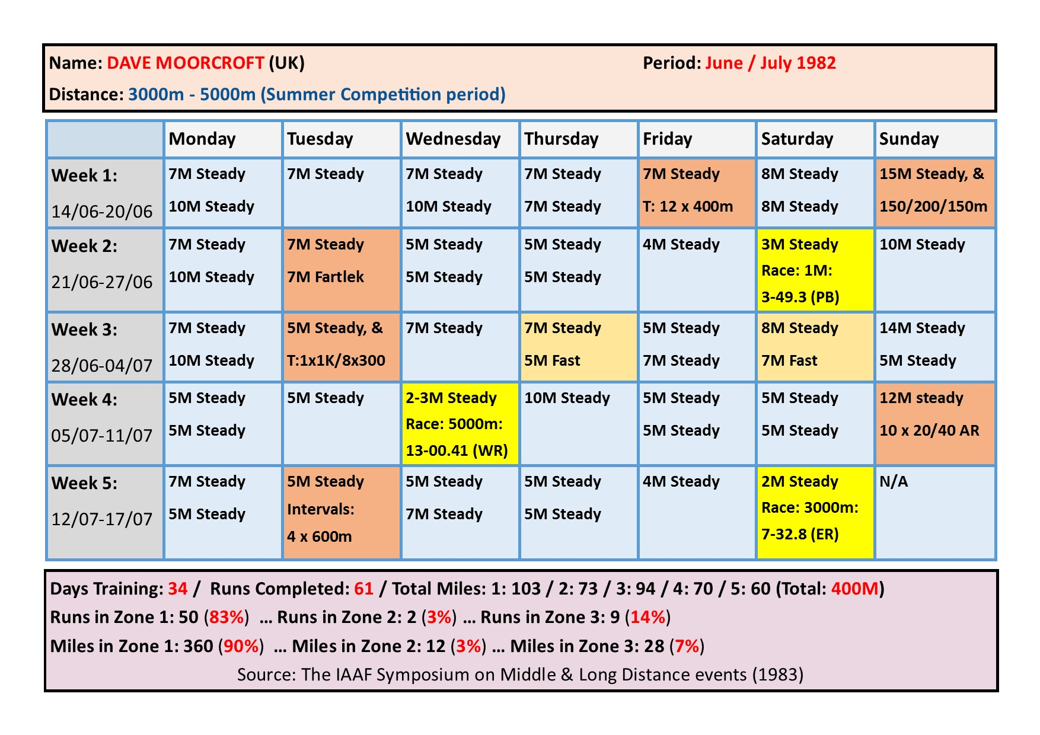

Example 2: Sonia O’Sullivan (1998)

The following training extract (featuring training in the month of her World XC wins in 1998) was taken from an article published on LetsRun.Com.
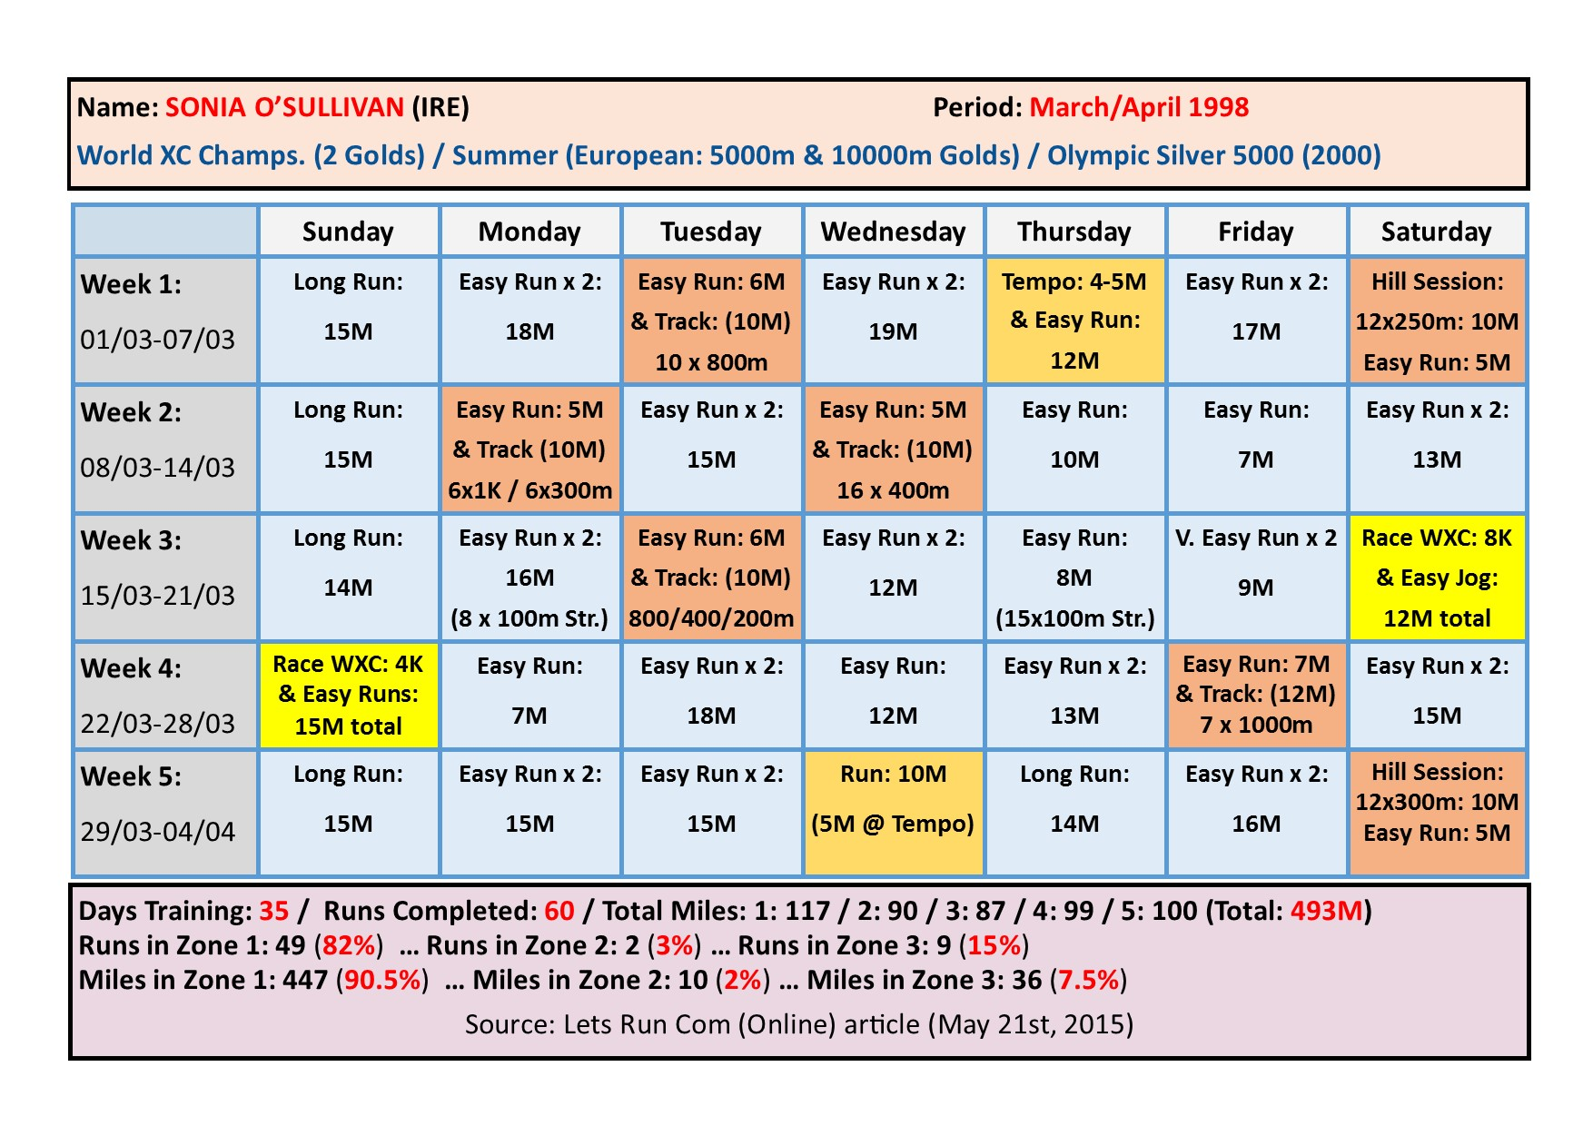
At first glance, the Dave Moorcroft example is very similar - in terms of structure and the number of higher intensity running sessions - to the example I provided last month based on my own training practice. True, there are occasions when Moorcroft takes just a single day’s recovery between higher intensity sessions, but there is also a minimum of three days of easy running prior to each race, and a minimum of two easy days immediately following each race effort.

With the Sonia O’Sullivan example, we see a similarly nuanced approach with a more high-density approach during race free weeks, but a significant number of easy days (& a low-density approach) in the 10 days leading up to her World XC championship races. Similarly, the training immediately following her race weekend is heavily characterised as ‘low-density’.

An interesting, and somewhat contradictory approach is evident in our next example.

Example 3: Brendan Foster (1974/76)

The following extracts are from Brendan Foster’s Autobiography, published in 1978.
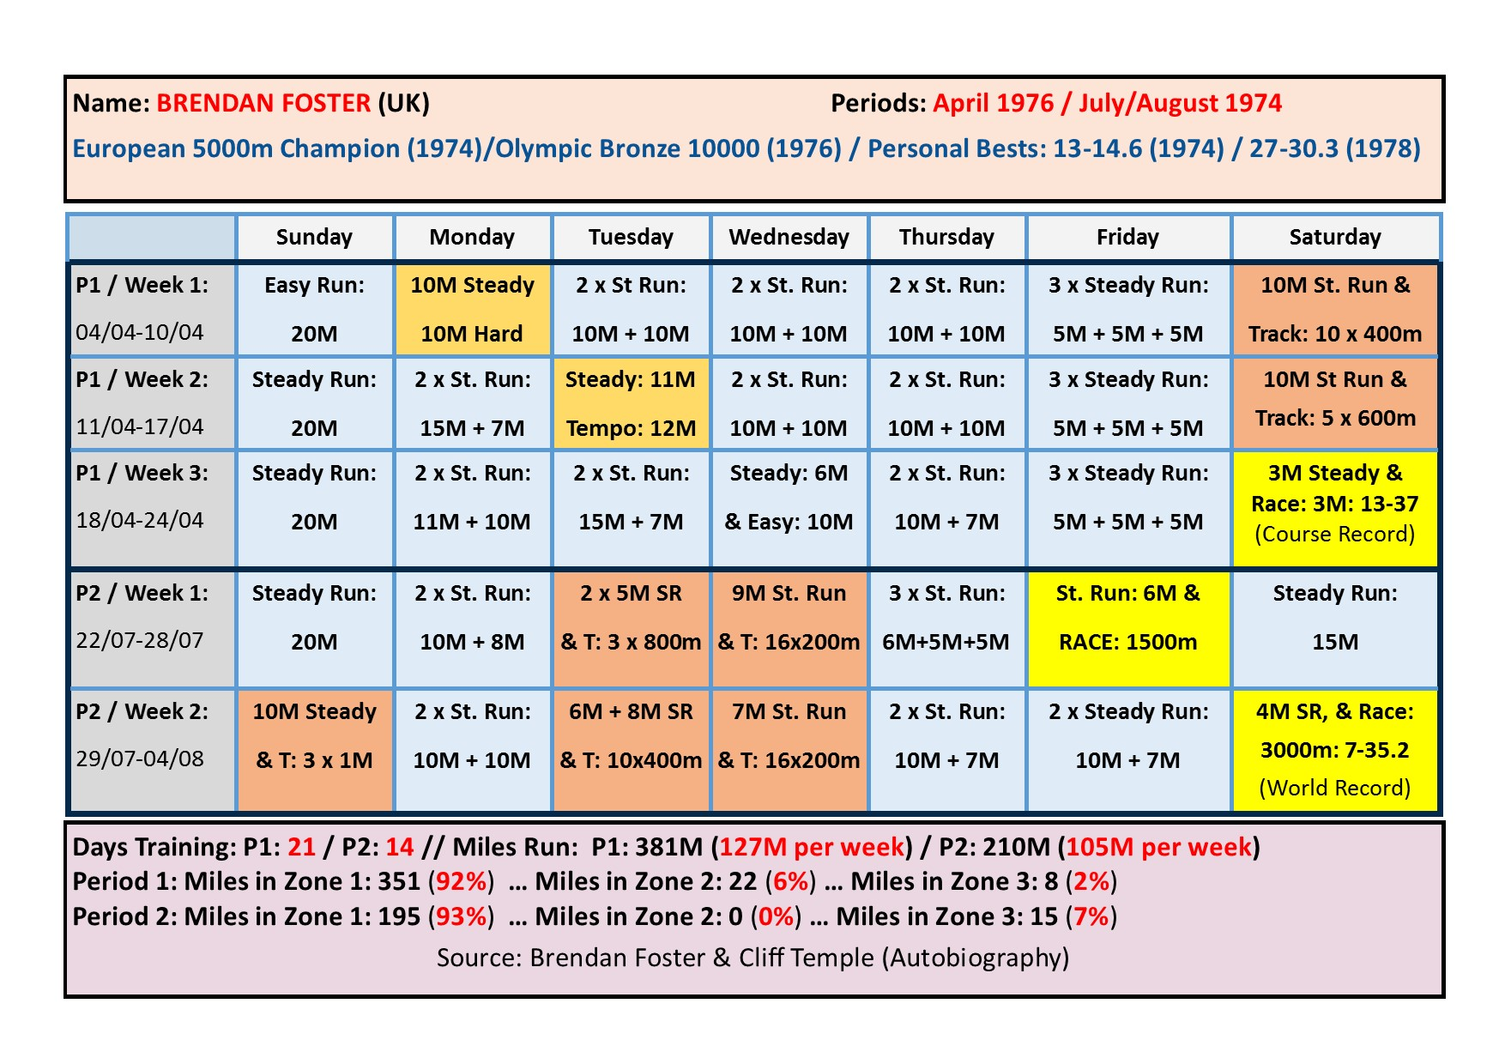
The first three weeks shown here are taken from April 1976 and details his training towards the end of his Winter period. Here the focus is clearly on training volume (mileage) and the density of training is low.

The second two-week period (July/August 1974) leading to his 3000m World Record, on the day of the official opening of the Gateshead International Stadium, is by comparison a period of high density training, where the focus is very much on building race pace through frequent track sessions.

This example clearly demonstrates that the training (for Foster) differed based on the precise stage of his periodised yearly training programme, with a low-density approach used during his ‘base’ phase, but a more high-density approach used in the Summer’s competition/track phase.

To round off, we shall consider the training of 2009 & 2011 World Championship Marathon Champion, Abel Kirui.

Example 4: Abel Kirui (2011)

The following data was initially provided by his coach (Renato Canova) on the LetsRun.Com forum, and subsequently shared on John Davis’ blog (Running Writings).
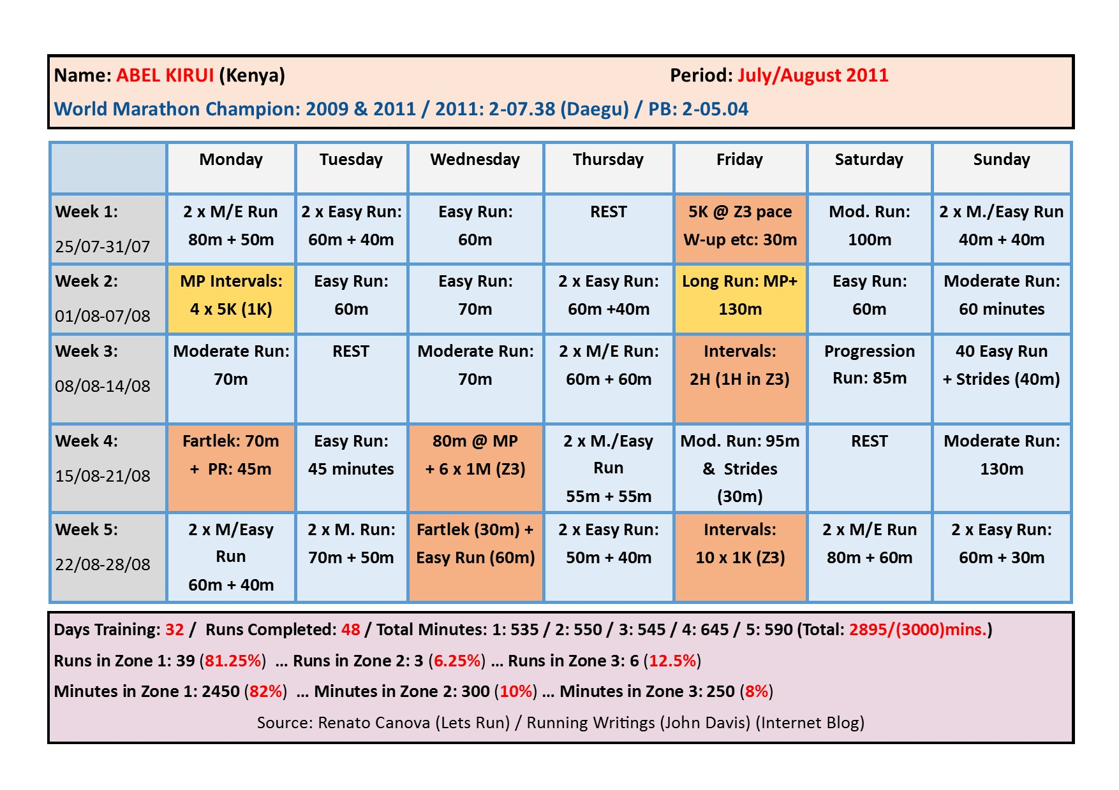

The data above, which relates to the weeks leading up to Abel Kirui’s World Championship Marathon success in 2011, demonstrates the finely balanced inter-play of high & low-density training as prescribed by Kirui’s coach, the world renowned Italian ‘master-coach’, Renato Canova.

Canova advocates a highly modulated training approach veering between days of very high intensity/duration (Note: Week 2/Friday & Week 4/Wednesday) and others of very low intensity/duration (Note: Rest Days in Weeks 1/3/&4). Of particular note are the number of recovery days (6!) following days of high intensity/duration.

Canova has famously noted that Western athletes training in Kenya invariably run too quickly on days that should be assigned as ‘easy’, whilst failing to reach the intensity levels demanded on days assigned as ‘hard’. He notes that, typically, Western athletes do not give sufficient respect to the need to balance high intensity workouts with sufficient days of low-intensity running (i.e. a low-density training approach).

Conclusions:

So, what lessons can we derive from the training practice of elite distance runners, past and present?

I would suggest that the following points are salient:

- Elite runners (as a rule) do not follow a regular weekly training structure, but follow a structure based around competitive targets
- Elite runners follow - in the main – low-density training programmes, with occasional periods of high-density training
- Elite runners respect the demands of high intensity races/workouts and plan training accordingly, with ample days of easy running before and after race-type efforts
- For elite runners, the training programme is a means to an end (competitive success) rather than a means in itself

We might expect that finely-tuned elite runners with years and years of dedicated training might be physically and mentally better prepared to follow a high-density training programme, with an emphasis on frequent high intensity/duration workouts. The evidence, however, is that they pay far more respect to the need to absorb, adapt, and respond to a training stimulus than do more average runners. On the whole, their training is: balanced; specific; and based on a low-density approach.

In short, the key lesson is that: elite runners ‘create space to flourish’.

About the Author:

Alan Maddocks competed from the mid 1970s to the early 2000s. He represented Wales, British Students, and Leicestershire, winning several local/regional races. Over the past decade Alan has advised and guided a small group of talented young runners/triathletes on to success at local, regional, national, and international level. In addition, he offers consultancy services, and is a regular contributor to the ‘Left Spike’ Fanzine.

Alan can be contacted at striders1@hotmail.co.uk

(For further details, see: https://beaconhillstriders.co.uk/)

