Beacon Hill Striders: Performance Running

Beacon Hill Striders Performance Running - https://beaconhillstriders.co.uk/ - aims to advise, guide, encourage, & inspire aspirational runners to adopt good/best training practice. To further this goal, I shall produce each month a short article offering both some insight and practical guidance. … This month’s article looks at an often-neglected feature of training programmes – ‘Training Density’.

BHS Monthly Article: February 2018

Training Density: Create Space to Flourish (Part 1)

The term ‘Training Density’ refers to the frequency that relatively ‘hard’ (in terms of training intensity or training duration) sessions are undertaken. If they are frequent with little in the way of ‘recovery’ days, then training density may be considered to be high. If they are less frequent with ample recovery days, then training density may be considered to be low. … This month (February) I shall examine this concept and provide examples of how I have used a relatively low-density approach for my own benefit and those of the athletes that I advise. … Next month (March) I shall look at how elite athletes (past & present) have in a similar fashion used a low-density approach to achieve world class performances.

Quality, Quantity, and Balance

Training programmes are often considered to be either quantity-focused (relying on high training volumes to bring about progression) or quality-focused (relying on high intensity training sessions to bring about progression). This is a false division. It is not a question of quantity or quality. The training programmes used by elite middle and long-distance runners clearly demonstrate that both quantity and quality matter.

Of greater importance is the balance between the two. Again, studies (#) of the training practice of elite middle and long-distance runners, provide us with the desired distribution of effort over a given time period. Such studies reveal that invariably elite runners spend 80% or more of training time/volume running at low intensity (below the aerobic threshold, roughly equivalent to a runner’s marathon race pace) and less than 20% of training time/volume at higher intensities.

Moreover, most successful training programmes are characterised by a ‘polarized’ approach, with the vast majority of training being at low-intensity but balanced by a small proportion of very high intensity training (training faster than the anaerobic threshold, roughly equivalent to 10K race pace).

A balanced training programme – based on the practice of elite athletes - therefore has both high training volume and a proportion of running at high intensity, with that balance weighted in an 80/20 (or in some cases 90/10) distribution.

# Foremost amongst these studies, is the work of Norwegian-based US Exercise Scientist Stephen Seiler who has documented the training programmes of elite endurance athletes in a number of endurance sports, including running.

Stimulus and Adaptation

Each training input (run/session) provides a training stimulus. The runner improves over time as a result of physiological adaptations to the training undertaken. These physiological adaptations in turn results in improved performance capacity.

Where the training stimulus is of a relatively low intensity (&/or duration) adaptation usually occurs very quickly. The runner absorbs the training stimulus readily. Highly experienced runners can for instance comfortably incorporate two runs of relatively low intensity each day for several days/weeks in a row.

A high intensity training input (or a training stimulus of extended duration), however, takes much longer to absorb and adapt to even for highly experienced and talented runners. As a result, following such training inputs, the runner may need to train at much lower intensities for a number of days before a comparable high intensity/duration training stimulus can be repeated.

A failure to allow sufficient recovery time can adversely affect performance capacity.

For instance, world-renowned US Exercise Scientist, David Costill (Ball State University) details in his book ‘A Scientific Approach to Distance Running’ (1979) the effects of three days of continuous hard effort in depleting the runner’s muscle glycogen stores, which in turn seriously impacts on the ability to perform.

A chronic failure to adapt to the training undertaken as a result of too frequent high intensity (or excessive duration) training inputs can have serious consequences. These consequences range from muscle soreness and fatigue on the one hand to increased risk of injury, illness, or mental burnout on the other.

A successful training programme tends to be one where the training is both sustainable and consistent. The purpose of any training programme is to provide improved performance capacity. This can only be achieved if the runner is able to absorb and adapt to the training undertaken.

Typical UK Training Format:

Famed US (University of Oregon) coach Bill Bowerman popularised the hard/easy training approach. This approach addressed the issue of adaptation discussed above and provided a template for designing training programmes that avoided the pitfalls of inadequate recovery from one training session to another.

The principle behind this approach is that a day characterised as ‘hard’ should be followed by another characterised as ‘easy’. The logic being that the ‘hard’ day provides the stimulus, whilst the ‘easy’ day allows the runner’s body time to recover and adapt. The subsequent effect is to enhance the runner’s performance capacity through a process known as ‘super-compensation’.

This hard/easy approach is common in the UK club system that tends to be based around three quality sessions (or races) per week, a long run day, and three days of relatively easy running. In the US Collegiate system, a more nuanced approach is often employed with 2 quality sessions and a long run per week.

As mentioned, in the UK many runners follow a weekly schedule, that includes three relatively high intensity sessions, along the following lines:

Mon: Easy Run
Tue: Track Session
Wed: Easy Run
Thu: Track Session (or Tempo Run)
Fri: Easy Run (or rest)
Sat: Race (or Hill/Grass Session)
Sun: Long Run

There is much to recommend this pattern of weekly training and many successful runners follow such a pattern. However, it is based on a big premise that 48 hours (or one ‘easy’ day) is sufficient ‘recovery’ from a high intensity/duration training session.

I would argue that this premise is basically flawed.

The rationale appears to be based more on an attempt to squeeze in all relevant training elements into a given week rather than heeding the need to adapt to a given training stimulus. Whilst, the above weekly format may work well for some, for many others it does not.

Alternative Practice

So, let’s consider an alternative format that is free of a repeated week in, week out type schedule. The following example (taken from my own running practice) details a month’s training from May 1986:
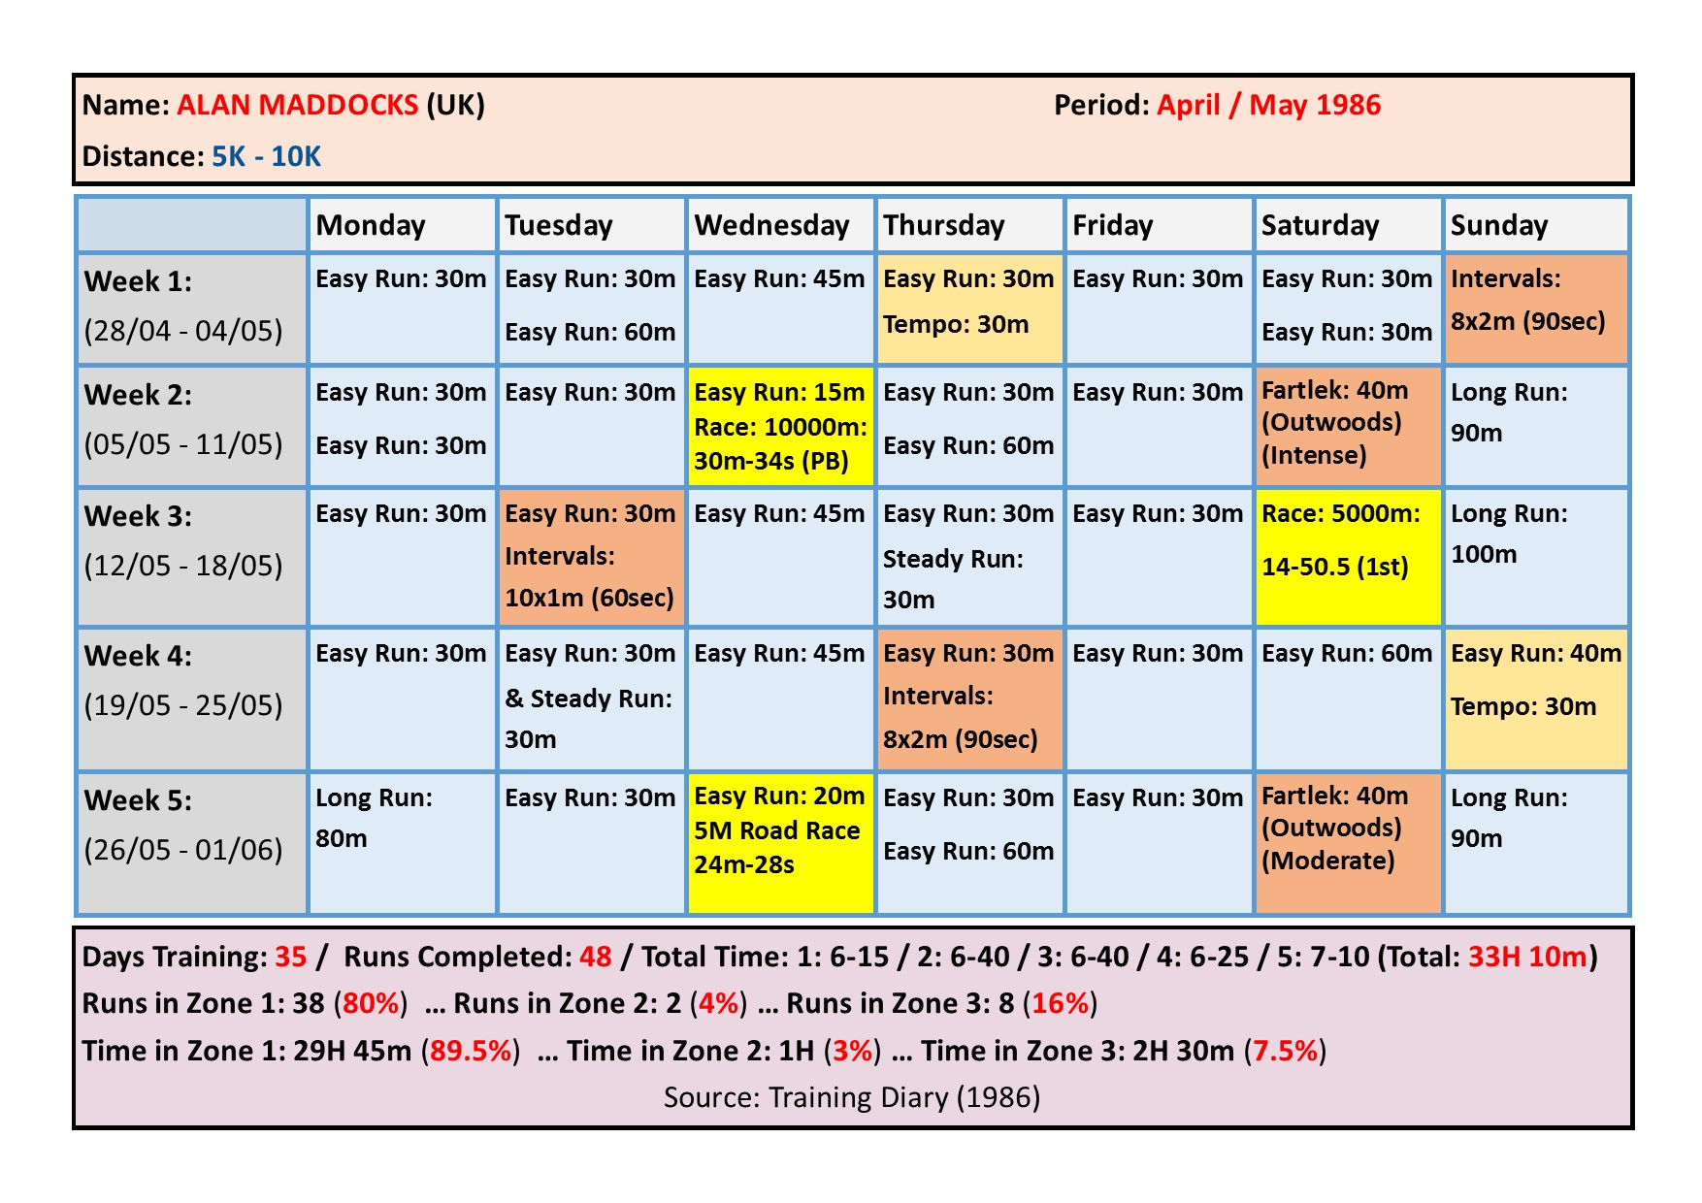

A quick glance at the above example shows that I took a minimum of two ‘easy’ days between ‘harder’ more intense training sessions (or races), and on occasions three ‘easy’ days. The schedule is not the same from week to week, though each week had two relatively ‘hard’ days, and usually a long run in excess of an hour.

The key to this pattern of training is to start with mapping each race you intend to do in the month ahead and then scheduling in appropriate training sessions to complement your race schedule, giving ample focus to sufficient ‘easy’ days between races and or training sessions.

I have used a similarly conservative (in terms of training density) approach with the young teenage athletes that I advise. Their successes at local, regional, national, & international level (including a number of national titles) is testament to the effectiveness of such an approach.

Conclusions:

To conclude, the following response - by highly respected US Coach Thomas Schwartz on his online ‘Run Zone’ forum - to a query on training density, summarises effectively the key messages I have put forward in this article:

In my view, about 80% of runners that I've met, been friends with, or coached, over the last 20 plus years have no need for training "hard" more than twice per week. A process goal related to this assertion is basic but fruitful: consistently put in two solid workouts per week during your build-up to a target race. Don't go crazy and push harder more often. You may get away with it for 3-4 weeks, but it will catch up to you. In most cases, fatigue, injury, or illness sets in by training beyond one's ability to absorb training (the load - the composite of intensity and duration; the density of that training is a key factor in invoking a stimulus that results in fitness and performance gains or results in degradation of the fitness base and the subsequent performance level). (Thomas Schwartz, Run Zone)

Next month: I shall examine how elite athletes (past and present) have used a low-density training approach to reap performances of the highest order.

About the Author:

Alan Maddocks competed from the mid 1970s to the early 2000s. He represented Wales, British Students, and Leicestershire, winning several local/regional races. Over the past decade Alan has advised and guided a small group of talented young runners/triathletes on to success at local, regional, national, and international level. In addition, he offers consultancy services, and is a regular contributor to the ‘Left Spike’ Fanzine.

Alan can be contacted at striders1@hotmail.co.uk

(For further details, see: https://beaconhillstriders.co.uk/)

