Beacon Hill Striders: Performance Running

Beacon Hill Striders Performance Running - https://beaconhillstriders.co.uk/ - aims to advise, guide, encourage, & inspire aspirational runners to adopt good/best training practice. To further this goal, I shall produce each month a short article offering both some insight and practical guidance. … This month’s article looks at the contrasting pacing strategies used at this month’s European XC Championships held on a typically continental (flat, dry, & twisty) course in Samorin, Slovakia.

BHS Monthly Article: December 2017

2017 European XC Championships: Pacing Strategies

The information/data used as the basis for this article was accessed from the detailed results service provided by European Athletics on their website: http://www.european-athletics.org/competitions/european-cross-country-championships/2017/schedules-results/ … The specific data used focuses on the individual splits for each ‘large’ (1500m) lap. … For this analysis I make the following assumptions: that each athlete took the most direct line whilst running, & therefore times provided reflect effort expanded; & that external (wind/temperature) conditions were the same across all races. The analysis focuses specifically on the three individual Men’s races, though I shall also comment upon the Women’s races in more general terms.

Men U20 Race:

The following table lists the top 10 finishers (and the GB athletes involved) listing their respective best times at 800m, 1500m, & 3000m (or 5000m, if superior):

Position | Name / Country |  | Time | 800m | 1500m | 3k/5k
1 | Jakob Ingebrigtsen | Norway | 18:39 | 01:49 | 03:39 | 08:00
2 | Ramazan Barbaros | Turkey | 18:41 | 01:49 | 03:41 | 08:18
3 | Louis Gilavert | France | 18:45 | x | 03:45 | 08:13
4 | Yani Khelaf | France | 18:47 | 01:52 | 03:41 | 08:14
5 | Miguel Gonzalez | Spain | 18:48 | x | 03:47 | 08:08
6 | Adrian Garcea | Romania | 18:48 | x | 03:51 | 08:14
7 | Annass Mahboub | Spain | 18:49 | x | 03:47 | 08:11
8 | Ignacio Fontes | Spain | 18:50 | 01:47 | 03:41 | x
9 | Mario Garcia | Spain | 18:50 | 01:52 | 03:42 | x
10 | Markus Gorger | Germany | 18:50 | x | 03:51 | 14:15
Team GB (If outside top 10) |  |  | Time | 800m | 1500m | 3k/5k
14 | Matt Willis | GB | 18:57 | x | 04:07 | 08:38
17 | Ben Dijkstra | GB | 19:01 | x | 03:53 | 14:22
25 | Will Richardson | GB | 19:10 | 01:57 | 03:49 | 08:14
27 | Scott Beattie | GB | 19:14 | 01:53 | 03:52 | 14:31
30 | Jake Heyward | GB | 19:23 | 01:50 | 03:42 | x
60 | Lachlan Wellington | GB | 19:49 | 02:05 | 04:02 | 08:37

The following table lists the same athletes and their respective split times for each of the 1500m laps covered (& the time for the final 90m run in):

European XC (U20M): 6.30 Km. (Including: 4 x 1500m laps)
Position | Name / Country | Lap 1 | Lap 2 | Lap 3 | Lap 4 | Finish
1 | Jakob Ingebrigtsen | 04:36 | 04:36 | 04:34 | 04:10 | 15
2 | Ramazan Barbaros | 04:37 | 04:37 | 04:32 | 04:11 | 17
3 | Louis Gilavert | 04:37 | 04:37 | 04:32 | 04:14 | 18
4 | Yani Khelaf | 04:37 | 04:36 | 04:34 | 04:16 | 17
5 | Miguel Gonzalez | 04:36 | 04:36 | 04:33 | 04:19 | 15
6 | Adrian Garcea | 04:37 | 04:36 | 04:34 | 04:21 | 13
7 | Annass Mahboub | 04:35 | 04:36 | 04:34 | 04:19 | 15
8 | Ignacio Fontes | 04:37 | 04:36 | 04:33 | 04:20 | 16
9 | Mario Garcia | 04:37 | 04:36 | 04:34 | 04:21 | 15
10 | Markus Gorger | 04:36 | 04:36 | 04:34 | 04:20 | 15
Team GB (If outside top 10) |  | Lap 1 | Lap 2 | Lap 3 | Lap 4 | Finish
14 | Matt Willis | 04:35 | 04:34 | 04:33 | 04:25 | 18
17 | Ben Dijkstra | 04:36 | 04:36 | 04:33 | 04:32 | 15
25 | Will Richardson | 04:36 | 04:36 | 04:35 | 04:38 | 17
27 | Scott Beattie | 04:36 | 04:36 | 04:34 | 04:42 | 17
30 | Jake Heyward | 04:38 | 04:38 | 04:44 | 04:40 | 15
60 | Lachlan Wellington | 04:38 | 04:45 | 04:46 | 04:43 | 15

The U20M race had an outstanding favourite in the reigning champion, Jakob Ingebrigtsen. It was unlikely - on all known form - that he would be inconvenienced by whatever pacing strategy that his opposition might employ. This may well have had the effect that his main opponents (on paper) just waited for something to happen rather than employ a more proactive race strategy. The outcome of this was that the race featured a steady pace for the first three (of four) large laps with a sizable number of athletes still in contention as they entered the final lap. The resulting ‘burn up’ resulted in the fastest three individual lap times across ALL the men’s races being recorded by the three medallists, in this youngest age group.

This particular race strategy clearly favoured those athletes with the best ‘speed’ credentials over the those whose forte is over longer (5000m/10000m) distances. The top 9 finishers all had outstanding track credentials across a combination of 800m, 1500, &/or 3000m. The distance specialists in the race, who might well have been expected to feature in the top ten, were literally blown away over the final lap. These included: our (Beacon Hill Striders) very own representative (2017 World JM Triathlon Bronze medallist) Ben Dijkstra * (17th); 2017 European 10000m U20M Champion (& European 5000m U20M Bronze medallist) Dorin Andrei Rusu (Romania) (12th); & 2017 European 5000m U20M Silver medallist, Tariku Novales (Spain) (13th).

* Note: I was inspired to conduct this overall analysis to understand more clearly what had effectively happened in the latter stages of this race, and to compare this with the U23M & Senior Men races. The lessons we have learned from this should help empower Ben to recognise and respond effectively to similar race situations in the future.

Men U23 Race:

The following table lists the top 10 finishers (and the GB athletes involved) listing their respective best times at 800m, 1500m, & 3000m (or 5000m, if superior):

Position | Name / Country |  | Time | 800m | 1500m | 3k/5k
1 | Jimmy Gressier | France | 24-35 | 01:54 | 03:43 | 13:50
2 | Hugo Hay | France | 24-37 | x | 03:43 | 13:52
3 | Yemanebehran Crippa | Italy | 24-42 | 01:50 | 03:38 | 13:36
4 | Emm. Roudolff-Levisse | France | 24-43 | x | 03:47 | 14:04
5 | Carlos Mayo | Spain | 24-46 | x | 03:41 | 13:34
6 | Simon Debognies | Belgium | 24-47 |  | 03:41 | 13:34
7 | Alexis Miellet | France | 24-47 | 01:47 | 03:39 | 08:15
8 | Topi Raitanen | Finland | 24-47 | x | 03:51 | 8:37 SC
9 | Robin Hendrix | Belgium | 24-48 | 01:49 | 03:40 | 08:11
10 | Suleyman Bekmizki | Turkey | 24-49 | 01:48 | 03:41 | 08:09
Team GB (If outside top 10) |  |  | Time | 800m | 1500m | 3k/5k
12 | Mahamed Mahamed | GB | 24-50 | 01:55 | 03:53 | 14:36
13 | Chris Olley | GB | 25-52 | 01:54 | 03:45 | 14:03
16 | Patrick Dever | GB | 25-02 | 01:54 | 03:44 | 13:59
25 | Joe Steward | GB | 25-13 | x | 04:05 | 09:04
31 | Jack Rowe | GB | 25-25 | 01:58 | 03:51 | 14:10
42 | Daniel Jarvis | GB | 25-34 | 01:55 | 03:48 | 08:21

The following table lists the same athletes and their respective split times etc:

European XC (U23M): 8.25 Km. (Including: 5 x 1500m laps)
Position | Name / Country | Lap 1 | Lap 2 | Lap 3 | Lap 4 | Lap 5 | Finish
1 | Jimmy Gressier | 04:43 | 04:36 | 04:30 | 04:23 | 04:16 | 15
2 | Hugo Hay | 04:43 | 04:38 | 04:29 | 04:25 | 04:15 | 15
3 | Yemanebehran Crippa | 04:41 | 04:36 | 04:30 | 04:21 | 04:21 | 18
4 | Emm. Roudolff-Levisse | 04:45 | 04:35 | 04:31 | 04:26 | 04:22 | 14
5 | Carlos Mayo | 04:41 | 04:35 | 04:31 | 04:23 | 04:25 | 17
6 | Simon Debognies | 04:44 | 04:35 | 04:30 | 04:24 | 04:25 | 17
7 | Alexis Miellet | 04:43 | 04:35 | 04:29 | 04:27 | 04:27 | 12
8 | Topi Raitanen | 04:42 | 04:37 | 04:29 | 04:27 | 04:24 | 14
9 | Robin Hendrix | 04:44 | 04:35 | 04:30 | 04:29 | 04:23 | 15
10 | Suleyman Bekmizki | 04:42 | 04:36 | 04:30 | 04:28 | 04:26 | 13
Team GB (If outside top 10) |  | Lap 1 | Lap 2 | Lap 3 | Lap 4 | Lap 5 | Finish
12 | Mahamed Mahamed | 04:43 | 04:37 | 04:29 | 04:25 | 04:28 | 16
13 | Chris Olley | 04:41 | 04:34 | 04:31 | 04:29 | 04:26 | 16
16 | Patrick Dever | 04:43 | 04:36 | 04:30 | 04:32 | 04:33 | 15
25 | Joe Steward | 04:41 | 04:37 | 04:33 | 04:36 | 04:35 | 15
31 | Jack Rowe | 04:41 | 04:37 | 04:34 | 04:39 | 04:43 | 16
42 | Daniel Jarvis | 04:40 | 04:37 | 04:37 | 04:46 | 04:42 | 15
The Men’s U23 race was (on paper) a more open race with Crippa, Mayo, & Mahamed having all recorded individual medal winning performances at these Championships in 2016, & Gressier having finished 4th in the U20M race in both 2015 and 2016. This experience played a part in that the leading protagonists ensured that the race was run to their specific strengths. A look at the personal bests of the leading protagonists revealed that the best/better 5K runners dominated.

The most striking feature of the pacing strategies used in this race was that the leading contenders were both patient (as witnessed by a relatively slow opening big lap) and spread their efforts into gradually increasing pace on each lap as the race progressed. The most striking injection of pace was provided by Crippa on lap 4 (with a 4-21 lap) that took him from 17th (at the end of lap 3) to 1st. This was a reprise of the tactics that he had used in 2015 to win the U20M race. On this occasion, however, it was not enough as he could only maintain this pace over the final big lap, whilst the French duo of Gressier (4-16) & Hay (4-15) came through decisively on the final lap to compete for the title. The French - as a team - ran very effective races with their next 2 runners also finishing strongly to claim 4th & 7th places respectively.

Crippa, on reflection, will probably regret making his move so far from the finish. As the athlete in the race with the best 1500m time, and with a devastating finishing burst in his armoury (having taken the 2017 European U23M 5000m title in devastating fashion with a last 200m kick), he could have chosen to play his cards at a much later stage of the race with, in all likelihood, a better outcome.

Senior Men’s Race:

The following table lists the top 10 finishers (and the GB athletes involved) listing their respective best times at 5000m, 10000m, & Half-Marathon:

Position | Name / Country |  | Time | 5000m | 10000m | H/Mar.
1 | Kan Kigen Ozbilen | Turkey/Kenya | 29-45 | 12:58 | 27:03 | 59:58
2 | Adel Mechaal | Spain | 29-54 | 13:15 | 29:25 | x
3 | Andrew Butchart | GB | 30-00 | 13:08 | 28:28 | x
4 | Hassan Chahdi | France | 30-01 | 13:42 | 28:36 | 61:38
5 | Soufiane Bouchikhi | Belgium | 30-04 | 13:22 | 28:07 | 63:45
6 | Ben Connor | GB | 30-08 | 13:29 | 28:23 | 64:13
7 | Aras Kaya | Turkey/Kenya | 30-14 | 13:23 | 27:48 | 63:49
8 | Daniel Mateo | Spain | 30-16 | 13:42 | 28:43 | x
9 | Polat Kemboi Arikan | Turkey/Kenya | 30-17 | 13:05 | 27:35 | 61:22
10 | Ayad Lamdassem | Spain | 30-18 | 13:17 | 27:45 | 61:22
Team GB (If outside top 10) |  |  | Time | 5000m | 10000m | H/Mar.
26 | Tom Lancashire | GB | 30-54 | 13:34 | 29:21 | x
38 | Alex Teuten | GB | 31-20 | 13:56 | 29:52 | 65:54
45 | Sam Stabler | GB | 31-31 | 13:30 | 29:03 | x

On paper, this was probably the hardest race to predict with a number of athletes having strong claims based on: previous experience at this event; strong current form; & impressive track and road running credentials. In the end the race came down to a fight between two track specialists (Mechaal & Butchart) and Turkey’s 31-year-old former Kenyan (& 2-06 Marathon runner) Kan Kigen Ozbilen. It was the latter who prevailed using all his experience to execute the best tactical use of personal strengths and resources throughout the race.

The following table lists the respective split times for the athletes in the previous table:

European XC (Senior Men): 10.20 Km. (Including: 6 x 1500m laps)
Position | Name / Country | Lap 1 | Lap 2 | Lap 3 | Lap 4 | Lap 5 | Lap 6 | Finish
1 | Kan Kigen Ozbilen | 04:25 | 04:25 | 04:24 | 04:22 | 04:21 | 04:19 | 15
2 | Adel Mechaal | 04:23 | 04:23 | 04:24 | 04:25 | 04:22 | 04:23 | 20
3 | Andrew Butchart | 04:24 | 04:21 | 04:24 | 04:26 | 04:26 | 04:28 | 17
4 | Hassan Chahdi | 04:27 | 04:27 | 04:23 | 04:24 | 04:32 | 04:23 | 14
5 | Soufiane Bouchikhi | 04:24 | 04:23 | 04:26 | 04:24 | 04:32 | 04:24 | 16
6 | Ben Connor | 04:24 | 04:21 | 04:24 | 04:27 | 04:33 | 04:29 | 15
7 | Aras Kaya | 04:29 | 04:26 | 04:24 | 04:26 | 04:30 | 04:26 | 17
8 | Daniel Mateo | 04:29 | 04:28 | 04:27 | 04:29 | 04:30 | 04:21 | 15
9 | Polat Kemboi Arikan | 04:21 | 04:22 | 04:28 | 04:30 | 04:32 | 04:30 | 16
10 | Ayad Lamdassem | 04:30 | 04:25 | 04:24 | 04:33 | 04:31 | 04:21 | 17
Team GB (If outside top 10) |  | Lap 1 | Lap 2 | Lap 3 | Lap 4 | Lap 5 | Lap 6 | Finish
26 | Tom Lancashire | 04:25 | 04:35 | 04:39 | 04:36 | 04:41 | 04:30 | 13
38 | Alex Teuten | 04:29 | 04:34 | 04:40 | 04:42 | 04:45 | 04:40 | 15
45 | Sam Stabler | 04:27 | 04:37 | 04:44 | 04:50 | 04:47 | 04:37 | 15

Ozbilen won the race by showing remarkable pace discipline. He increased his pace very marginally from lap to lap and come through very strongly on the final two laps to claim the title. Having been placed 10th at the end of the opening big lap, he gradually progressed to 5th at the half-way stage (end of lap 3). At this stage he was 5 seconds adrift of the leader. From there, he kept moving through, taking the lead at the end of the penultimate lap before forging clear on the final lap. As a Half-Marathon/Marathon specialist he used his strength and stamina to maximum effect.

The Silver medallist (Mechaal) displayed remarkable pace consistency throughout the race with only two seconds separating his fastest and slowest laps. This consistency however proved no match for the winner’s surge over the final two laps but secured the individual Silver over his fellow track specialist, Butchart. Butchart ran a brave race, but his effort to run away from his opposition so early in the race (lap 2) blunted his ability to compete over the final two laps. Further down the order, the strong closing couple of laps from the Spanish duo of Mateo & Lamdassem secured team Silvers for Spain, just three points adrift of the successful Turkish/(Kenyan) team.

Women’s Races:

The Women’s races were run in very different fashion to the men’s races with decisive breaks occurring very early in each race. In the U20W race GB’s Harriet Knowles-Jones used her considerable experience of this event (2nd in 2015; & 3rd in 2016) to power away from the half-way point, covering the final big (1500m) lap 10 seconds quicker than he nearest rivals. The Senior Women’s race was also decided early as the reigning champion (Turkey’s Yasemin Can) took the lead on the opening big lap (of 5) & proceeded to extend her lead on each subsequent lap. The U23W race provided the most dramatic exhibition of front running as the German duo of Alina Reh & Konstanze Klosterhalfen effectively ran away from their opposition from the outset. Reh’s more consistent pacing securing the win by a margin of three seconds, as a further twenty seconds separated the German duo from the Bronze medallist, GB’s Jessica Judd. Judd, in her attempts to follow Reh & Klosterhalfen, in turn created a sizable gap that the chasing pack were unable to close. This race demonstrated the sheer brutality of the effects of early pace where superior athletes dominate from the outset.

Conclusions:

So, what conclusions can we draw?

I would argue that the following points on race/pace strategy may be helpful for the competitive runner:

- If you believe that you are far superior to your opposition, then a strong early pace to break-away in the early part of a race is a sound strategy, providing that you are confident that you can maintain that pace to the end
- If you are clearly not far superior to your opposition, then early injections of pace may prove to be detrimental to your overall performance
- The ability to close quickly is paramount. (Six of the nine medallists – and all three race winners - in the men’s races featured above) ran quickest in the final stages of their races
- Run to your strengths. If you have strong middle-distance (800/1500m) times compared to your main opposition, then conserve your energies for the final part of the race. If your strengths are more stamina-focused, then gradually apply pressure throughout the middle portion of a race. If possible, very gradually increase pace throughout the duration of the race
- Whichever strategy you choose to employ, maintain pace discipline. It’s always better to run your own race than to be responding to the strategies of others

About the Author:

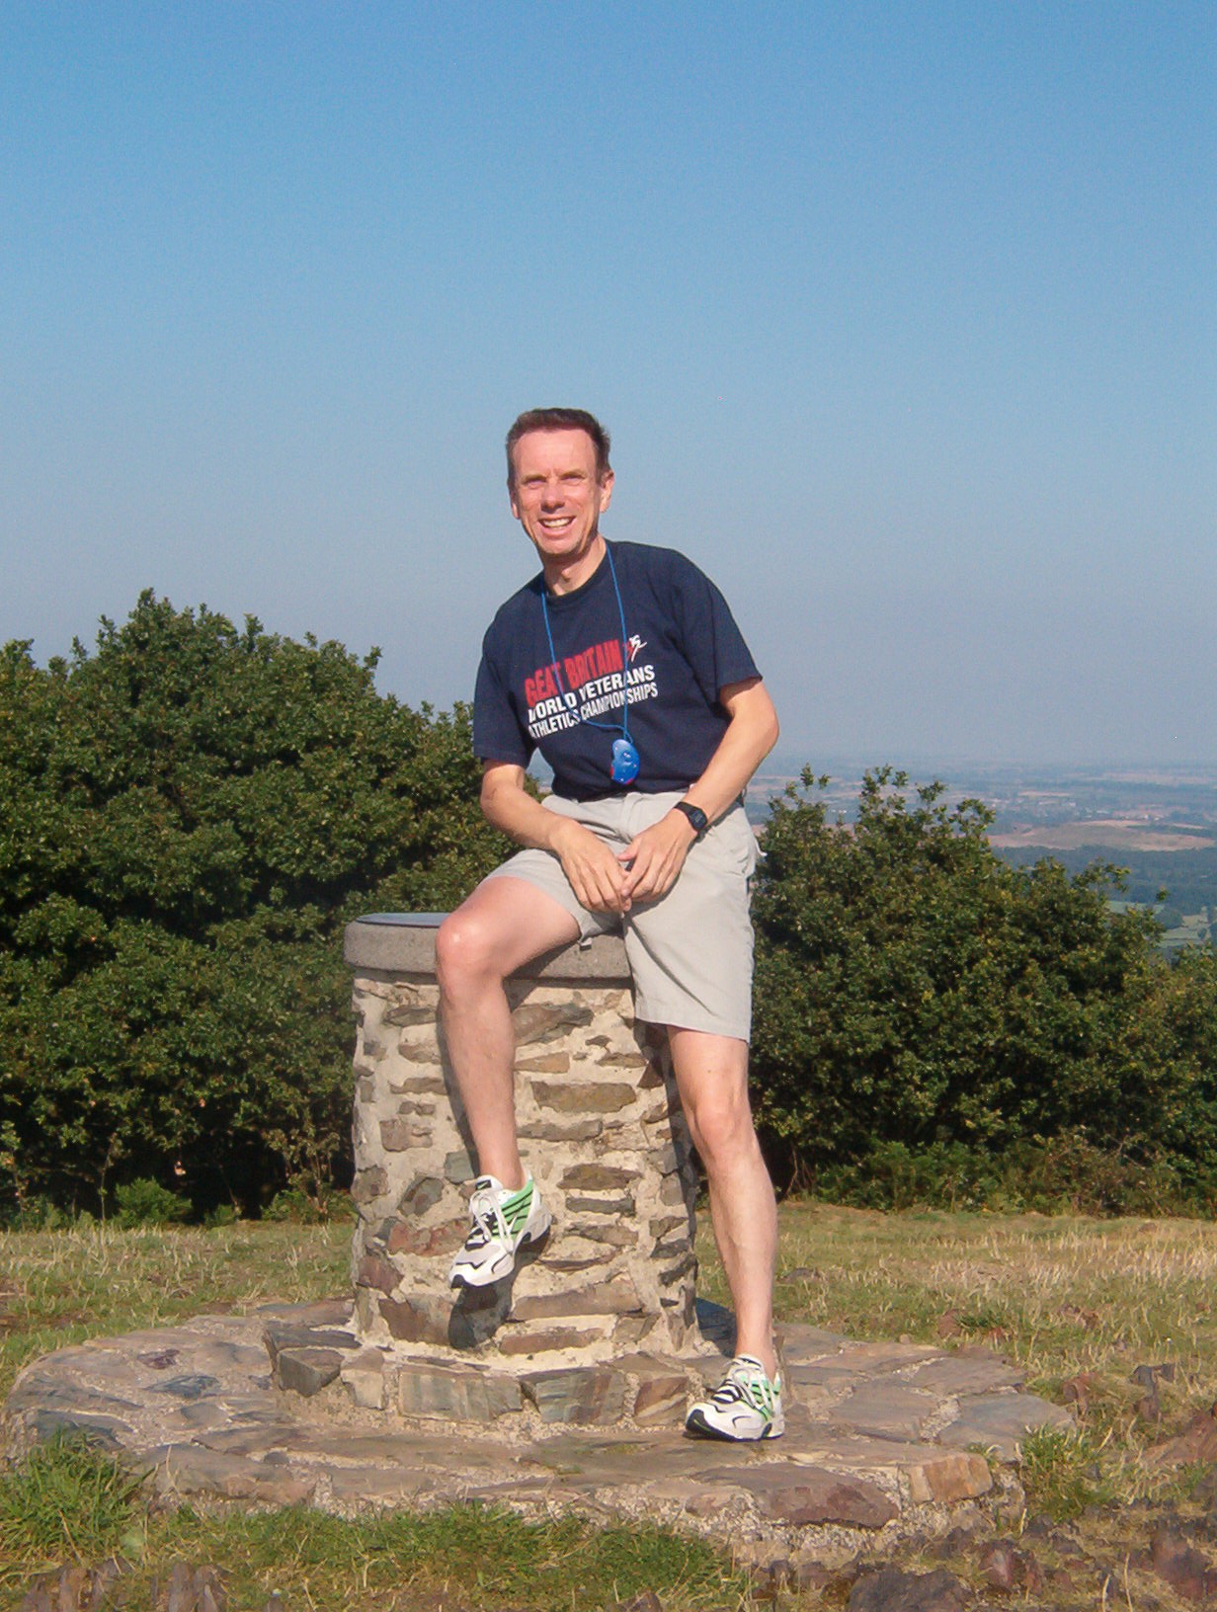Alan Maddocks was a successful runner, competing from the mid 1970s to the early 2000s. He represented Wales, British Students, and Leicestershire, winning several local/regional races. Over the past decade Alan has advised and guided a small group of talented young runners/triathletes on to success at local, regional, national, and international level. In addition, he offers consultancy services, and is a regular contributor to the ‘Left Spike’ Fanzine.

Alan can be contacted at striders1@hotmail.co.uk

(For further details, see: https://beaconhillstriders.co.uk/)

