Beacon Hill Striders: Performance Running

Beacon Hill Striders Performance Running - https://beaconhillstriders.co.uk/ - aims to advise, guide, encourage, & inspire aspirational runners to adopt good/best training practice. To further this goal, I shall produce each month a short article offering both some insight and practical guidance. We open with an article that looks at the anatomy of a successful cross-country season experienced by the author.

BHS Monthly Article: October 2017

The Anatomy of a Successful Cross-Country Season
(In Praise of the Steady Run)

This month’s article seeks to offer any aspirational runner embarking on their cross-country (XC) season both a template to follow, and a steer in terms of balancing training between aerobic ‘steady’ running and more intense sessions.

The article focuses on a 14-week period of training (September to December 1985) in which I won the overall individual North Midlands XC League title. I shall outline the training completed month by month, and then draw together the salient points that any aspirational runner should take from my experience.

Prior to the period under scrutiny, I had spent a low-key couple of months running on average just 30 miles per week and enjoying my ‘summer holidays’ both at home and abroad. (I was a teacher at the time). The final week prior to the period under scrutiny was a 45-mile week involving six easy runs of 30 to 60 minutes duration.

September (4 weeks)

With the opening race of the 4-race League series scheduled for the middle of October (end of Week 6) my initial focus was very much on building a more solid base following the relative inactivity of the previous couple of months. I opted to follow a hard/easy pattern of training, with Mondays, Wednesdays, and Fridays involving short aerobic recovery runs (plus some additional basic supplementary exercises: sit-ups, push-ups etc.). From Week 2 onwards two runs were completed on Tuesdays & Thursdays.

Week | M | T | W | TH | F | S | S | Total: | MPW: | Monthly | Runs:
1 | 30m | 65m | 30m | 65m | 30m | 65m | 90m | 6H 15m | 55 | 55 | 7
2 | 30m | 85m (2) | 30m | 90m (2) | 30m | 60m | 90m | 6H 55m | 60 | 115 | 9
3 | 30m | 95m (2) | 30m | 95m (2) | 30m | x | 95m | 6H 15m | 52 | 167 | 8
4 | 30m | 95m (2) | 30m | 95m (2) | 30m | 60m | 90m | 7H 10m | 60 | 227 | 9

The weekends involved longer runs with a traditional Sunday long run of 90+ minutes becoming a regular weekly feature. In September, I ran every day bar the Saturday of the third week when I had to attend a wedding. The vast majority of the running was done off-road, much of it on quite demanding hilly terrain in the Charnwood Forest area near my Loughborough home. Towards the end of Week 4, I introduced my first up-tempo session of the period, running a fartlek session on mixed terrain that involved six ‘hard’ efforts of 3 minutes duration, with a similar 3-minute recovery.

Summary: During September, I completed 33 runs (average of 8.25 runs per week), covering a total of 227 Miles. All the runs bar one were ‘aerobic’ in nature, though the hilly terrain ensured that much of this was ‘challenging’ rather than ‘easy’.

October (4 weeks)

During October I built upon the foundations of the previous month by maintaining a very similar pattern of running. From Week 5 onwards it became apparent that I was gaining fitness as on the steady hour runs (Tuesday, Thursday, and Saturday) my training diary (from which the data in this article has been sourced) shows comments such as: ‘felt good’; ‘moving well’; ‘moving smoothly and relaxed’; ‘strong pace’; ‘finished strongly’. The steady running was clearly taking effect.

Week | M | T | W | TH | F | S | S | Total: | MPW: | Monthly | Runs:
5 | 30m | 95m (2) | 30m | 95m (2) | 30m | 60m | 95m | 7H 15m | 64 | 64 | 9
6 | 30m | 90m (2) | 30m | 90m (2) | x | 60m | 90m (2) | 6H 30m | 56 | 120 | 9
7 | 30m | 110m (2) | 30m | 90m (2) | 30m | 45m | 90m | 7H 05m | 62 | 182 | 9
8 | 45m | 80m | 65m | 95m | 30m | 60m | 95m | 7H 50m | 67 | 249 | 7

The Saturday of Week 5 was the same Fartlek as for Week 4 but with a shorter (2-minute) recovery between the efforts. By now I felt ready to race, and surprised myself (given how little ‘faster’ running I had done for over three months) how well I ran in the opening XC race of the season at a sun-drenched Markeaton Park, Derby (finishing 5th, covering the advertised 9.6K in 28-47). The quality of the race was sound with both the winner and the second being current English International XC runners.

The following Thursday (Week 7) I joined a group Fartlek session (a similar session to those I had run in Weeks 4 and 5) with the (Loughborough) University middle/long distance group. Week 8 was School half-term, which I spent up in Keswick (Monday to Friday), and involved some slow-paced runs due to the unevenness of the rock-strewn Lake District trails. (The week also involved a significant number of hilly walks). The Saturday was another Fartlek, this time involving prolonged efforts on some hills.

Summary: During October I completed 34 runs (average of 8.5 runs per week), covering a total of 249 Miles. The vast majority of runs remained ‘aerobic’ in nature, with one weekly effort (session or race) involving demanding work.

November (4 weeks)

On the Tuesday of Week 9 I joined the University distance running squad for my first track session of the winter (24 laps of slow/fast 200s: a session based on the ‘Oregon 30/40 200m Workout’). I was again surprised as to how well I went, covering the 24 laps (6 miles) in 32-30 and leaving a number of very talented athletes in my wake. I therefore approached the Saturday race with some confidence. The confidence was not misplaced as I finished 2nd 100m down on the winner of Race 1, covering the advertised 10.2Km - on a fast but undulating course at Berry Hill Park, Mansfield - in 29-54. (I assume that the exact distance was less than 10K)

The following week (Week 10) I again joined the University squad for a track session of 5 x 1M (60 seconds, 200m jog recovery). I averaged 4-55 despite the wet and windy conditions. This effort, so soon after Saturday’s race (or the 2-Hour Sunday run at the end of the week), may have been a mistake as the following week (Week 11) I came down with a heavy cold that curtailed my training, with just one effort session (a controlled 5M Tempo Run) on the Thursday.

Week | M | T | W | TH | F | S | S | Total: | MPW: | Monthly | Runs:
9 | 30m | 90m (2) | 30m | 90m (2) | x | 60m | 90m | 6H 30m | 57 | 57 | 8
10 | 30m | 90m (2) | 45m | 90m (2) | 30m | 60m | 120m | 7H 45m | 68 | 125 | 9
11 | 30m | 90m (2) | 30m | 90m (2) | 30m | 30m | 60m | 6H | 52 | 177 | 9
12 | 30m | 60m | 45m | 70m (2) | x | 60m | 95m | 6H | 53 | 230 | 7

I was still not fully recovered the following week (Week 12), but toed the line at the 3rd Race (at Wollaton Park, Nottingham) in the XC League series, as I knew I was now in a challenging position for the overall title. The decision to race was vindicated by a 3rd place finish, 18 seconds down on the race winner. With the winner of the previous two fixtures absent, I was now in lead position for the overall title, with a 50-second cushion to the next best placed runner (positions being decided by aggregate time).

Summary: During November I completed 33 runs (average of 8.25 runs per week), covering a total of 230 Miles. Again, most of my runs remained ‘aerobic’ in nature, with (apart from Week 9) one weekly effort involving challenging work.

December (2 weeks)

Just two weeks remained before the final XC League fixture. The following week (Week 13) I resisted the temptation to back-off, and recorded a 67-mile week including a ‘medium discomfort’ (tempo) run of 5 Miles in 25-10 on the Thursday evening, having eased off after hitting the 3 Mile mark in 14-50.

Week | M | T | W | TH | F | S | S | Total: | MPW: | Monthly | Runs:
13 | 30m | 90m (2) | 50m | 90m (2) | 30m | 80m | 90m | 7H 40m | 67 | 67 | 9
14 | 30m | 90m (2) | 50m | 90m (2) | x | 60m | 95m | 6H 55m | 60 | 127 | 8

During the final week (Week 14) I again joined the Tuesday night track session averaging 4-45 for each repetition of the 4 x 1M session (2 minutes jog recovery).
Saturday’s race (at Sutton-in-Ashfield) was something to look forward to. With a 50 second cushion, only a mishap during the race was likely to derail my challenge for the overall title. Fortunately, there were no unforeseen incidents, and I could run the final lap of the race with gusto, closing down fast on the eventual victor, narrowly missing the race win by a mere second. Sunday’s run (despite much stiffness from the previous day’s exertions) was a most satisfying experience, as I reflected upon my efforts over the Autumn months.

Overall Summary: Across the 14-week period (98 days) I had run on 93 days, completing 117 runs in total. Of these runs, 54 had been runs of an hour or more. (The vast majority of the others being 30-minute recovery runs). This consistency was reflected on a week-by-week basis as I averaged just under 60 miles a week, with a lowest weekly total of 52 miles, & a highest of 68. Most of the runs (104) had been ‘aerobic’ in nature, with the remainder involving 4 races and 9 specific training sessions (Fartlek, Track Repetitions, and Tempo Runs). In short, 90% of runs were easy/steady, with the remainder involving challenging training. (A mix of training that follows the classical polarized training model).

Lessons:

So, what lessons can be drawn - from my experiences over thirty years ago - for the benefit of the aspirational runner of today about to embark upon their XC season? I would argue that the main take-away points are as follows:
- Frequent (daily) and consistent training is more important than an overall volume figure. (My overall volume was relatively modest, but it was consistent)
- Create a base of steady running before introducing specific sessions.
- Frequent intense (hard) sessions are not necessary, and may indeed be counter-productive. A single, well-structured, session per week may well suffice.
- Mix up your intense sessions. (Include: Fartlek; track sessions; and tempo runs)
- Do not underestimate the power of steady running, especially over off-road, hilly terrain. (A regime of frequent steady hourly runs is a powerful training method)
- Target your training effort towards specific races. Always have a Plan.

Finally, the true test of any training plan is whether it enables you to achieve your goals. ‘Smart’ training always trumps ‘hard’ training. Learn from experience.

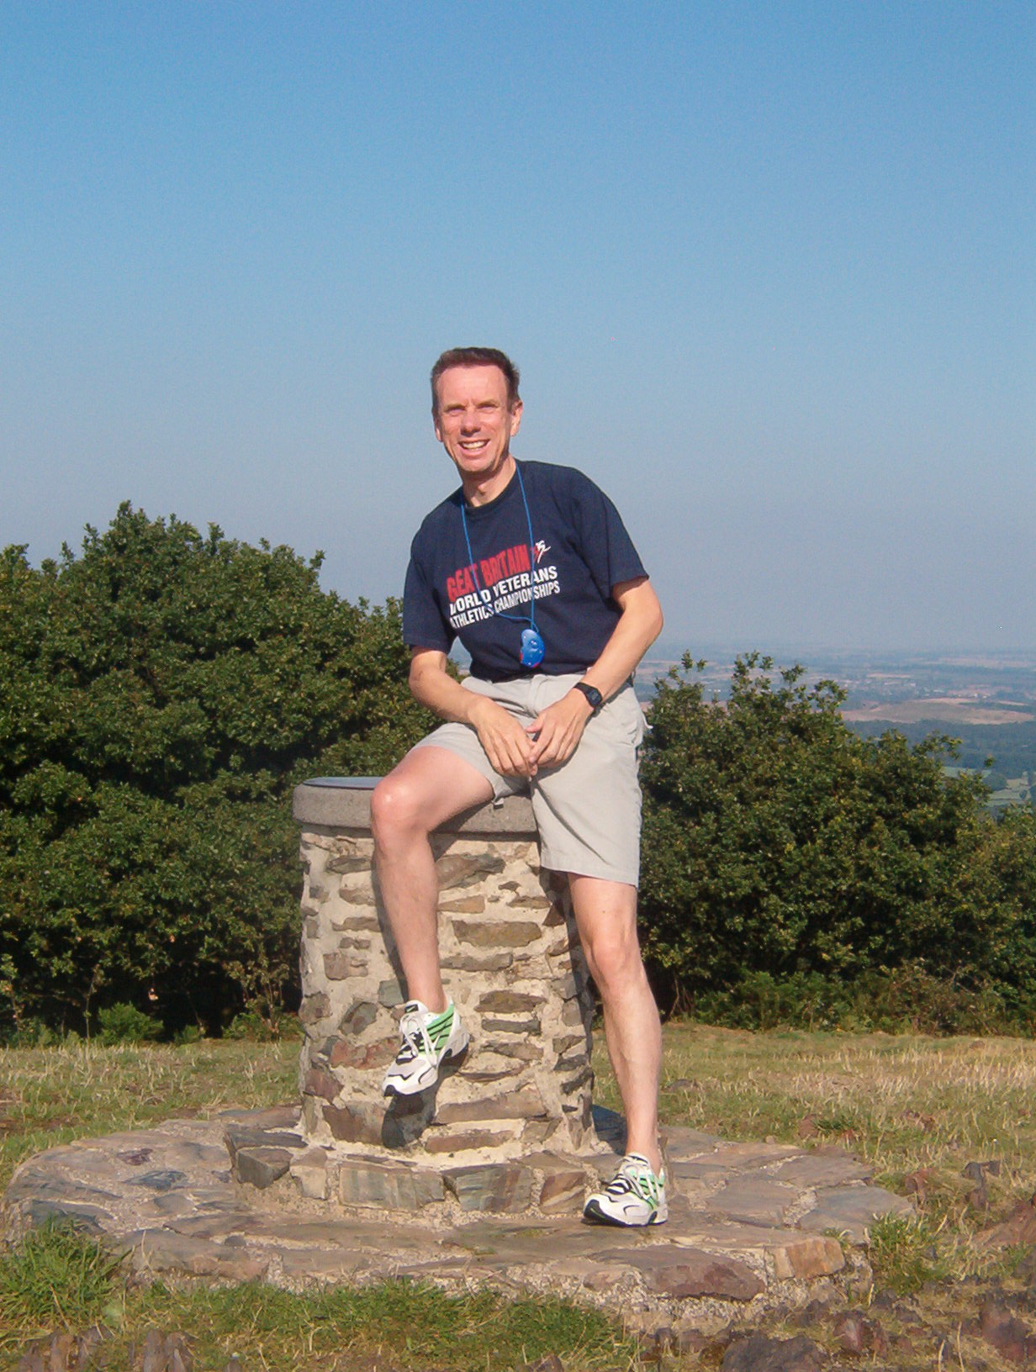
About the Author:

Alan Maddocks was a successful runner, competing from the mid 1970s to the early 2000s. He represented Wales, British Students, and Leicestershire, winning several local/regional races. Over the past decade Alan has advised and guided a small group of talented young runners/triathletes on to success at local, regional, national, and international level. In addition, he offers consultancy services, and is a regular contributor to the ‘Left Spike’ Fanzine. Alan can be contacted at striders1@hotmail.co.uk

(For further details, see: https://beaconhillstriders.co.uk/)

