The ‘Golden Age’ of UK 10000m Running

This article seeks to: examine some of the reasons why the 1970s & 1980s formed the ‘Golden Age’ of UK 10000m running; inform the aspirational runner of today about the training practices common at this time; and to enthuse and encourage aspirational runners to set their sights on achieving similar time standards.

(It should be noted that the article does not relate to Women’s 10000m running, as women did not have the opportunities to compete at this distance until the late 1980s. Similarly, it must be noted that prior to the 1970s, UK distance runners would tend to run imperial distances rather than metric distances)

This is a longer, more comprehensive version of an article first published in Left Spike (Issue 9) that formed the programme for the Highgate Harriers ‘Night of the 10000m PBs’ on May 20th, 2017.

The Stats

The image below (taken of the leaders in the 1977 English National XC Championships at Parliament Hill) captures the strength of UK 10000m running at the time.

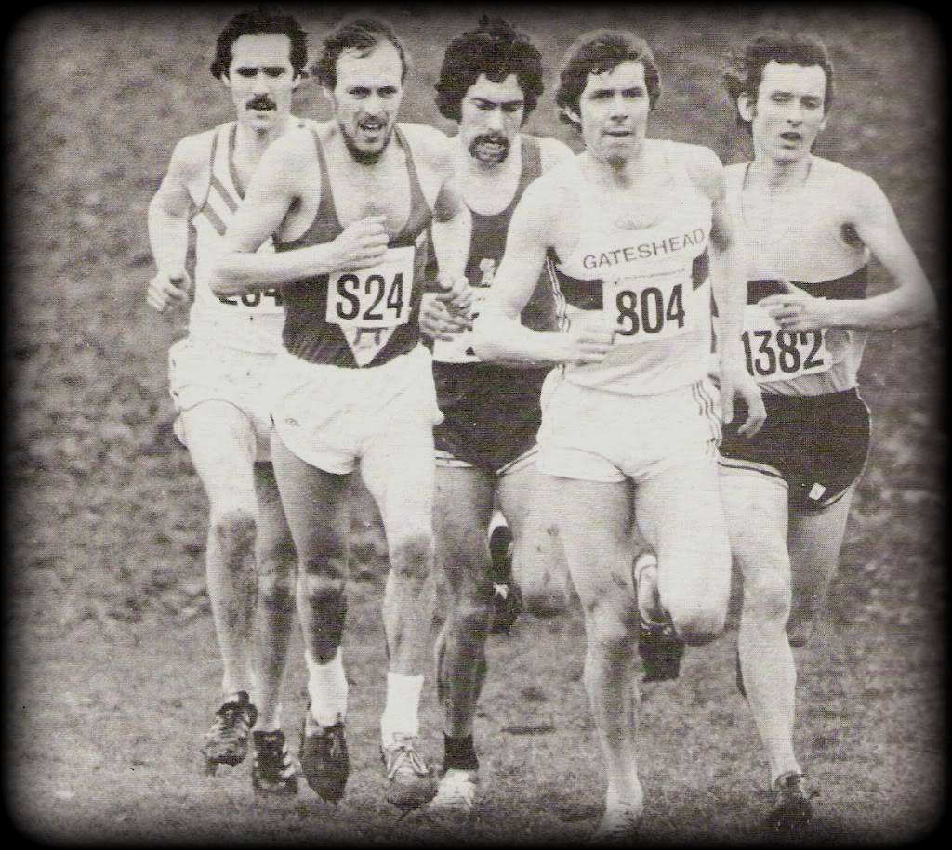

The athletes are (from left to right): Dave Black (10000m best of 27-36.27); Mike McLeod (27-39.76); Bernie Ford (27-43.74); Brendan Foster (27-30.3); & Tony Simmons (27-43.59). All five athletes are listed in the top 16 of the UK All-Time (AT) 10000m lists, and here they all are – captured in this one image - in the same race.

A perusal of the AT (All-Time) lists clearly shows the strength of UK 10000m running in the 1970s & 1980s compared to the present day.

Of the top 50 times (28-13.04 of faster) 30 (60%) were recorded before 1990. Of the 31 sub 28 minute times, 19 (61.29%) were recorded in the 1970s or 1980s; and the same period accounts for 7 of the top 10 times (70%).
…………………………………………………………..

Pictured on the right:

No.21: Nick Rose (27-31.19): set in 1983: UK AT 7th; &

No.9: Julian Goater (27-34.58): set in 1982: UK AT 8th.

(Both were winners of the English National XC Championships: Rose in 1980; & Goater in 1981)

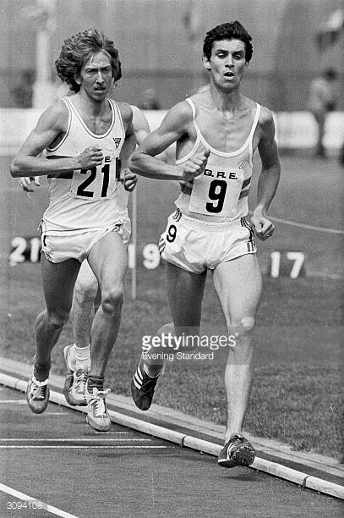

…………………………………………………………….

By contrast, within the last decade, only five UK men (Mo Farah; Chris Thompson; Andy Vernon; Ross Millington; & Andrew Lemoncello) have breached the 28-minute mark.

Despite all the modern advantages of better track surfaces, advanced shoe technology, enhanced nutritional knowledge, advanced scientific knowhow, ready access to altitude training, and better understanding of running physiology, today’s runners have collectively failed to match the achievements of those of a generation ago.

What can account for the obvious disparity between today and the ‘Golden Age’ of the 1970s & 1980s?

Several factors are in play, but I shall focus on the following cultural (in both the broader and – more specific - athletics sense) factors:

* Athletics/Running Club - structure and ethos
* Race programme and opportunities
* Training practices
* Confidence and Self-Belief

1970/80s Club Culture

Prior to the running boom of the mid/late 1980s, all running/athletics clubs were populated by serious competitive runners. Fun/social runners were decidedly in the minority. All runners trained seriously and consistently with the aim of competing to the best of their abilities. Shared endeavour produced a high degree of loyalty and a focus on collective efforts for the ‘team’/club. The goal was always to excel collectively locally, regionally, and nationally. Performances at County, Area and National Championships were highly valued. There would be considerable pride in the achievements of the club as a whole, and the achievements of individuals within the club.
……………………………………………………………….

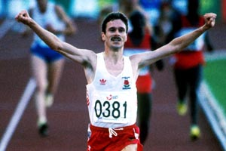
Pictured on the Left:

Eammon Martin (27-23.06): 1988: UK AT 3rd.

(Martin was a regular competitor for his club in National XC & Road Relay events)

…………………………………………………………….

The outcome arising from this strong club culture and emphasis on competitive performance was that clubs enjoyed a depth of running talent. Runners would push each other on in training and competition to reach new heights.

With information on running practice not easy to come by in the days prior to online/social media, knowledge of training practice was in-house, shared and passed on. Older runners passed on their knowledge and experience to the younger runners within the club. Most ‘coaches’ or mentors had considerable competitive experience, and understood both the commitment and sacrifice required to excel within the sport. Younger runners as a result developed training habits that were based on tried and tested methods, and had ready access to a wealth of knowledge and experience within their club to overcome challenges and setbacks.

Competition between clubs was intense. Considerable kudos was had from being the best club in the county or region, and all runners strived to make their club team for major national events such as the National XC Championships or the National Road Relays. Within the strongest clubs, the effort to rise to the top of the club was often sufficient to earn a number of club members individual international honours.

In short, the structure, ethos, traditions, collective experiences, and mutual support within each club provided the ideal breeding ground for runners to push their boundaries and to test themselves to the full.
Race Programme

Another aspect that contrasts with the modern setting was the traditional race programme. There was a clear hierarchy of competitions that all runners would respect, and consequently the best athletes would follow very similar yearly racing programmes.

In the Winter the focus would be on cross-country with League, County, Inter-Counties, Area, & National Championships seen as priority competitions that nearly all athletes within a club – including the very best – supported.

As Winter transitioned into summer the Area and National Road Relays provided both a focus for club competition, and a testing-bed for the very best runners to gauge their fitness against past performances. In a similar vein, top runners regularly competed against each other on the track during the Summer months across a range of distances.

There were fewer race opportunities, particularly on the road, and it was unusual to see top runners pursuing vanity projects by stepping down to minor races that they would not be thoroughly tested in.

The end result was that top runners competed relatively frequently and would race each other regularly throughout the year. This pushed runners on to fresh heights, as to achieve regional or national titles, runners had to perform at a very high level throughout the year. The quality and depth of opposition ensured that victories were well merited.

Training Practice

Whilst there would be variations from one athlete to another in terms of training specifics, all distance runners logged significant weekly mileages. It would have been unusual for those near the top of the National rankings in 10000m running or cross country to be running less than 90-100 miles a week for most of the year.

……………………………………………………………….

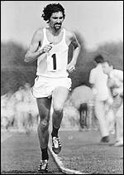
Pictured Left:

Former 10000m World Record Holder, Dave Bedford (27-30.8): 1973: UK AT 6th.

Bedford was a prodigious trainer, logging well over 100 miles per week. In preparation for his English National XC Championship win in 1971, he ran 6 weeks averaging 188 mpw, a week at 140 mpw, and a race week of 100 mpw. (Source: Middle and Long Distance Marathon and Steeplechase; written by Dennis Watts & Harry Wilson; BAAB; 1975)

……………………………………………………………..
In addition, to big mileage totals throughout the year, there would have been a distinct contrast between Winter training and Summer training.

Winter training would have focused on creating a ‘base’ for faster running in the Summer. Typically, it would have involved up to 90-95% of running completed at easy/steady paces. Faster running would often be confided to XC races and weekly Fartlek sessions. The occasional 6-10 mile ‘sustained’ run might also feature. Track interval sessions were usually avoided – or, at least, were uncommon - during the Winter months.

(It is - in my view - no coincidence that the decline in distance running standards in the UK & Europe has coincided with the much greater availability of all-weather tracks since the mid/late 1980s).

Towards the end of Winter, the Road Relays would often be used as a test of the effectiveness of the training done over the Winter to establish a foundation of ‘strength’ on which to build speed upon.

In the Summer months training volumes would be marginally reduced, but still maintained at around 80-85% of Winter volume. Summer training was characterised by a polarized training approach with 75-80% of the training mileage at easy/steady paces but the remaining percentage involving demanding anaerobic interval training over a range of distances from 200m up to 2000m. It would not be out of the ordinary for a serious athlete to complete three track interval sessions a week during this period. Some Fartlek running and shorter (3-5 miles) sustained runs might well also feature.

(Further Training details based on the information supplied by Brendan Foster in his 1978 autobiography are provided at the end of this article.)

Confidence and Self-Belief

One thing that runners in the 1970s and 1980s were not short of was confidence and self-belief.

UK runners in the 1970s and 1980s had not experienced the years and years of African domination that today’s runners face. They were competitive at international championships, and accustomed to gaining medals at European, Commonwealth, and Olympic level. Such success often breeds the self-belief and confidence needed to compete with the best.

………………………………………………………………..

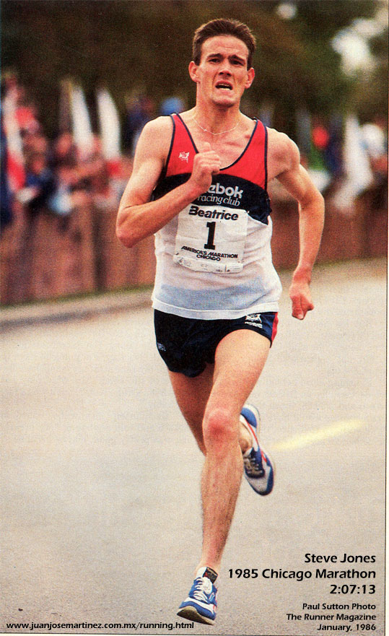
One athlete that was certainly not short of confidence was World Marathon Record Holder Steve Jones.
(Pictured Left)

Jones, whose 10000m best was 27-39.14 (1983) (UK AT 10th) was a regular competitor for his club, Newport Harriers, notching up a record nine (senior) Welsh National XC Championship titles.

Much like Bedford, Jones displayed his confidence and self-belief through pushing the pace in races from the outset. He saw his front-running tactics as a challenge for his opposition; a challenge which they often failed to meet.

……………………………………………………

Lessons

So, what lessons might today’s aspirational runner draw from this ‘Golden Age’ of distance running? I would suggest the following:

* Acquaint yourself as fully as possible with the training practices of those runners who excelled during this period. Note the balance between faster and slower running (see next section), and how these runners had a different training emphasis between Winter and Summer months. Aim to work towards - over time - the training volume, intensities (& distribution of each) common in their training practices.
* If possible, seek out these runners and ask for their advice. If this is not possible, seek advice and guidance from those with considerable racing experience at a high level. (It is my belief that the most knowledgeable coaches out there, are those with this kind of competitive experience)
* Race regularly, support your club, and seek out high level competition. In particular, Area and National Championships (XC, Road, Road Relays, & Track) should form the mainstay of your racing programme.
* Recognise that success in distance running is based on years and years of commitment to training. Don’t believe that gimmicks or short-cuts, ‘marginal gains’, or regular periods at altitude, can replace the consistency of week-in, week-out training.
* Develop and foster self-belief and a can-do mentality.
Appendix: Analysis of Training Methods

As way of demonstrating the type of training common to the leading runners of the 1970s & 1980s the following (extracted from Brendan Foster’s Autobiography: Brendan Foster; Brendan Foster & Cliff Temple; Heinemann (London); 1978) is provided as an illustration of training methods. (An analysis is provided to highlight key features)

The first (three-week) period featured is the training done towards the end of the Winter base-building period, transitioning into the Summer track season of 1976. (Foster would go on to claim the Olympic 10000m Bronze medal later that Summer).

The second period featured is the two-week period leading up to Foster’s 3000m World Record at Gateshead Stadium in August 1974. Foster would go on to win the European 5000m title in Rome a few weeks later.
(See: https://www.youtube.com/watch?v=tIumqbnwokc)

Period 1: April 1976: (End of Winter Base Building)

04/04: 20M easy
05/04: 10M steady & 10M hard
06/04: 10M steady & 10M steady (with three hard stretches)
07/04: 10M steady & 10M steady
08/04: 10M steady & 10M steady
09/04: 5M steady & 5M steady
10/04: Track: 10 x 400m with 90 seconds rest (5.5M) & 10M steady
(weekly total: 131.5 miles)

11/04: 20M steady
12/04: 15M steady & 7M steady
13/04: 11M steady & 12M steady
14/04: 10M steady & 10M steady
15/04: 10M steady & 10M steady
16/04: 5M steady & 5M steady & 5M steady
17/04: Track: 5 x 600m with 2 minutes rest (6M) & 10M steady
(weekly total: 136 miles)

18/04: 20M steady
19/04: 11M steady & 10M steady
20/04: 15M steady & 7M steady
21/04: 6M steady & 10M easy
22/04: 10M steady & 7M steady
23/04: 5M steady & 5M steady & 5M steady
24/04: 3M steady & Race: National Road Relays at Sutton Park, Birmingham: 3.08M in 13-37 (course record by 15 seconds)
(weekly total: 126 miles)

Comment/ Analysis:

The above example illustrates the focus (at this time of year) on maximizing the total volume of running. Within the three week period provided, Foster covered a total of nearly 400 miles, with just 2 track sessions and one race. (How does this compare with today’s training practices?). Whilst Foster (along with Bedford and a few others) ran such prodigious mileages, the majority of other leading distance runners (& many club runners) would be running totals in excess of 100 miles per week. To do so required a trade-off in terms of how much ‘quality’ running could be accomplished. Nearly all of the training done was in the aerobic range. The effort required was immense, & the comments provided in Foster’s training diary for the above period is littered with words/phrases such as: ‘tired’; ‘very tired’; ‘very fatigued’; ‘extremely tired’; & ‘felt stiff’. For those who might think this volume is a recipe for injury, it is worth noting that Foster claimed to have missed just 5 days of training through injury throughout his career.

Period 2: July/August 1974: (Summer track season)

21/07: 20M steady
22/07: 10M steady & 8M steady
23/07: 5M & 5M & Track: 3 x 800m (4 minutes rest) & 4 x 100m
24/07: 9M steady & Track: 8 x 200m (20 seconds rest) & 4 x 100m
25/07: 6M steady & 5M steady & 5M steady
26/07: 6M steady & Race: 1500m (3-41.2)
27/07: 15M ‘quite fast’
(weekly total: 110 miles)

28/07: Track: 3 x 1600m (average: 4-10.18!) & 10M steady
29/07: 10M steady & 10M steady
30/07: 6M steady & Track: 10 x 400m with 90 seconds rest & 8M steady
31/07: 7M steady & Track: 8 x 200m (20 seconds recovery)
01/08: 6M steady & 8M steady
02/08: 5M steady & 5M steady
03/08: Race: 3000m: 7-35.2 (world record!) & 4M steady
(weekly total: 100+ miles)

Comment:

Of note is that although the volume at the height of the track season is down on the previous time period provided, it is still in excess of 100 miles a week (with a weekly long run of 15-20 miles still as the cornerstone of the training). Track sessions are very intense but not high in total volume of faster running. Although 85-90% of training volume is still of low intensity, the remaining proprtion is of a very high intensity. This ‘polarized training’ approach appears to be that favoured by the vast majority of elite endurance athletes (& has been shown by some research work – Salzburg Study; Stoggl & Sperlich – to be the most effective distribution of intensities in eliciting high performance outcomes). Also of note is the nature and degree of tapering practiced by Foster for what was (& was intended to be) a key race performance, to mark the opening of the Gateshead International track. There was only a minimal reduction in training volume, but (crucially) no high intensity training conducted in the 48 hours prior to race day.

