MARCH 2016 PRESENTATION/TALK

Monday, March 21st, 2016 @ Woodhouse Eaves Village Hall

SUMMARY REPORT

On the evening of Monday, March 21st, Alan Maddocks (Beacon Hill Striders: Performance Running) presented a talk entitled:

‘Balanced Training – How Elite Endurance Athletes Train’

The 50+ strong audience included: local athletes (young & old); parents; and local coaches. The majority of the audience were Leicestershire based though there were representatives from Cumbria, Northamptonshire, Nottinghamshire and Warwickshire also present.

In addition to the 2 hour presentation, the audience had the opportunity to quiz Beacon Hill Striders’ World Junior Duathlon Champion & multiple national championships winner on road, track & XC, Ben Dijkstra.

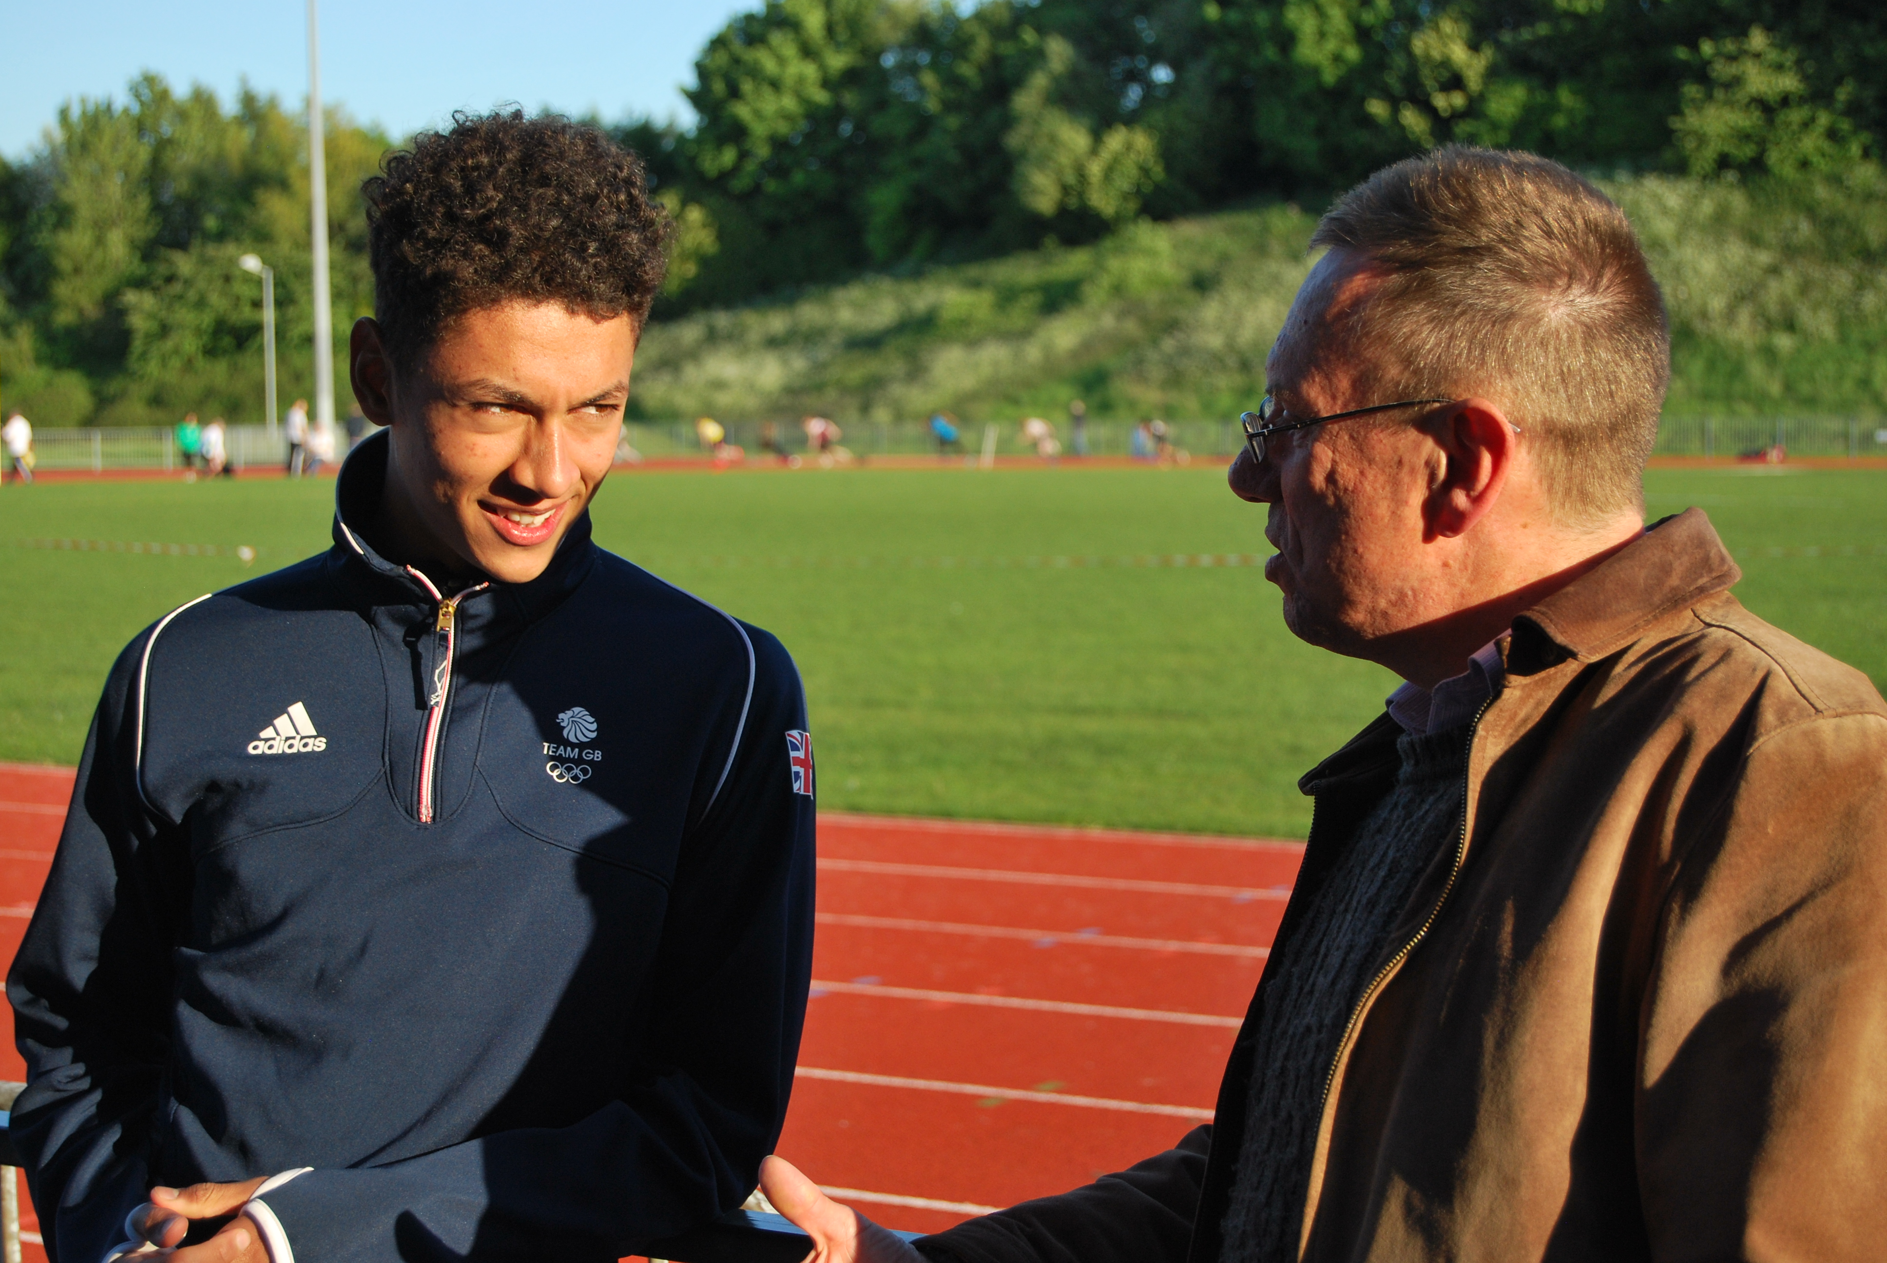
Ben impressively answered a range of questions from the audience, including questions on: his training volume; his pre-race nutrition; how he balances his training with (school) work commitments; & how he started in the sport. He talked about his experiences in competing abroad at World and European Championships, as well as competing locally. The only question that Ben declined to answer - from a rival competitor, Isaac Akers (2016 English National U17M XC Champion) - was to his tactical plans for an upcoming race that they were both scheduled to appear in.

(Photo: Ben Dijkstra, pictured with Alan Maddocks at a BMC Regional race meeting in Tipton, Birmingham, June 2015)

Alan began his presentation by providing a quick overview of key training principles, before examining in more detail the range of training intensities that endurance athletes use. Alan identified three main training intensity zones (Zone 1: low intensity / Zone 2: medium intensity / & Zone 3: high intensity) separated by distinct physiological markers, namely the aerobic threshold and the lactate threshold.

Alan continued by presenting research findings that show that elite athletes tend to spend a greater proportion of their training time at low intensity (Zone 1) compared to recreationally competitive runners. Furthermore, he also quoted research findings that demonstrated that the most successful elite runners were those who spent the greatest proportion of their training time at low intensities.

Amongst the research findings provided were those by renowned sport & exercise scientists, Stephen Seiler and Jonathan Esteve-Lanao.

(For those looking for a taste of these research findings the following link should be of interest: Stephen Seiler presentation)

Having looked at the ‘research’, Alan provided in depth analysis of the Training Logs of a number of elite athletes from both the past and the present. Athletes featured ranged from those whose specialist distances were 800m/1500m through to the Marathon. Amongst the athletes featured were a number of Olympic/World Champions, and/or World Record holders. These included: Abel Kirui; Brendan Foster; Dave Moorcroft; Frank Shorter; John Walker; Sebastian Coe; & Sonia O’Sullivan. Each athlete’s Training data was displayed visually for the benefit of the audience. (See example below)
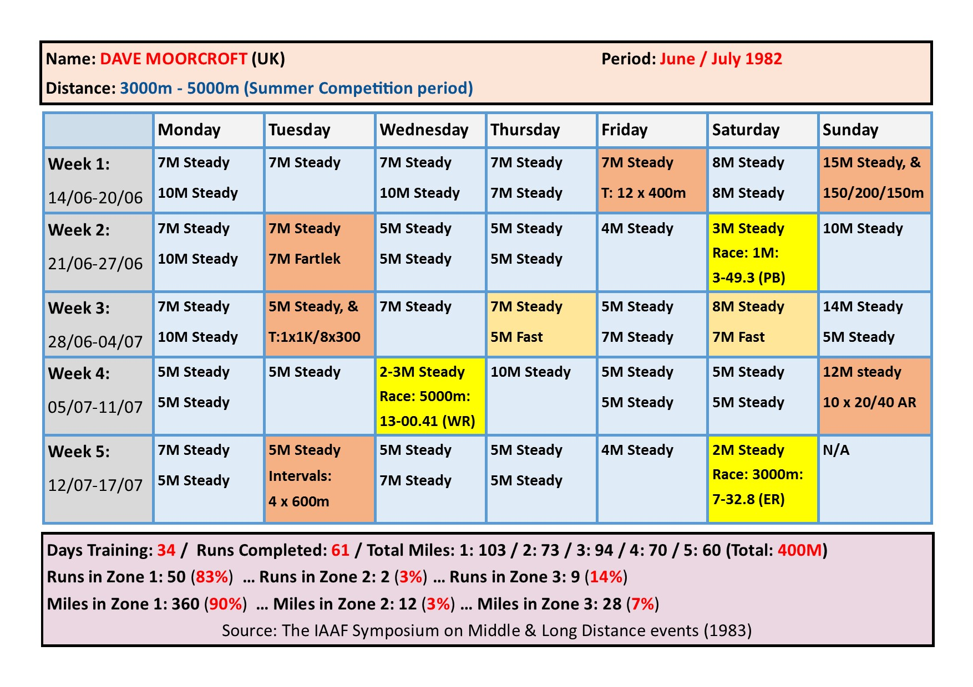
It was noted that for all the athletes featured that:
- The distribution of training intensities confirmed the research findings presented
- Elite endurance athletes spent typically 80-90% of their training time within the low intensity zone (Zone 1)
- For most of the athletes featured, the remaining proportion of time was spent predominantly in the high intensity zone (Zone 3), displaying in the process a “polarized” training pattern that research findings (The Salzburg Study) had demonstrated to be the most effective distribution of training time and effort
- Elite athletes, on the whole, follow a training pattern built around intended races, rather than following a standard weekly pattern

Alan concluded the evening by answering a series of questions from the audience. These included:

- How the Beacon Hill Striders training programme reflected the training patterns described
- Whether teenage athletes should engage in twice daily training
- Whether track training was an essential feature for elite endurance athletes
- Whether any world-class endurance athletes exhibited a training intensity distribution different from the 80/20 approach featured

The Key Points to arise from Alan’s presentation were:
- That elite endurance athletes spend a significant proportion (80-90%) of their training time at low intensity (Zone 1)
- That research indicates that non-elite athletes spend disproportionately a greater amount of their time at higher intensities (Zones 2 & 3)
- That research findings indicate that the most effective distribution of training intensities for ALL endurance athletes involves a “polarized” approach, involving training in Zones 1 & Zones 3
- That elite endurance athletes plan their training around their race commitments rather than employing a standard weekly template
- That a balanced training approach – as used by elite athletes – offers the best training approach for endurance athletes of all abilities

The presentation was very well received by those present, with the following quotes amongst the audience feedback subsequently received after the event:

- “Many thanks for your excellent presentation last night” (S.G.)
- “I enjoyed the talk, very thought provoking” (T.M.)
- “I’ve left feeling most reflective … excellent” (B.L.)
- “An excellent evening … we’d certainly attend another one” (M.A.)
- “The combination of research evidence and real life examples worked really well” (R.A.)
- “Very informative and interesting” (K.W.)
- “Thank you for a very enjoyable evening” (D.R.)

For a range of running training related articles, please visit the:
Beacon Hill Striders Running (Performance Running) Resource Centre: http://beaconhillstriders.co.uk/resource-centre/

The next talk/presentation … subject/theme to be confirmed … is scheduled for September/October 2016. … Details to follow.

